INTERNSHIP PROJECT REPORT

AI-ENABLED STUDENT ADMISSIONS SYSTEM

A Project Report Submitted as Part of the Salesforce Internship Program

Submitted By
Name: NADUPURU KUSUMA
Email: kusumanadupuru@gmail.com
Registration Number: 23331A05C0
Department: Computer Science and Engineering
College: Maharaj Vijayaram Gajapathi Rai College of Engineering (MVGR), Chintalavalasa, Vizianagaram, Andhra Pradesh

Internship
Salesforce Certified Administrator with AI Agentforce Specialization

Submitted To
SmartBridge Educational Services Pvt. Ltd.
Salesforce Internship Program

Internship Duration
May 2026 – July 2026

Academic Year
2025 – 2026

Department of Computer Science and Engineering
Maharaj Vijayaram Gajapathi Rai College of Engineering
Affiliated to JNTU Gurajada Vizianagaram, India
A CRM APPLICATION
FOR
AI-ENABLED STUDENT ADMISSIONS & SUPPORT MANAGEMENT SYSTEM

User Story
As an Admission Counselor, I want to efficiently manage student admissions using a Salesforce-based Student Admissions & Support Management System. I want to maintain student records, manage course information, track enrollments, and automate admission workflows through approval processes and flows. I also want AI-powered assistance to generate student application summaries, analyze enrollment risks, and recommend approval decisions using Agentforce AI. Additionally, I require automated email notifications, reports, and dashboards to monitor admission activities and improve decision-making while enhancing the overall admission experience for students.

1. INTRODUCTION

1.1 Project Overview
The project "AI-Enabled Student Admissions & Support Management System" focuses on developing a Salesforce-based admission management solution that automates the complete student admission lifecycle. The application manages student information, course details, student enrollments, approvals, notifications, and AI-assisted admission processes. It leverages Salesforce's declarative features, including Flows, Approval Processes, Reports, Dashboards, and Agentforce AI, to improve operational efficiency and provide intelligent decision support.

1.2 Purpose
The purpose of this project is to:
- Automate the student admission process.
- Manage student, course, and enrollment records efficiently.
- Improve data accuracy through validation rules.
- Automate approvals and email notifications.
- Generate reports and dashboards for admission analysis.
- Enhance decision-making using Agentforce AI.
- Improve overall student admission management through automation.

2. IDEATION PHASE

2.1 Problem Statement (Customer Problem Statement Template)
PS | I am (Customer) | I'm trying to | But | Because | Which makes me feel
PS-1 | Admission Counselor | Manage student admissions efficiently | Student records are managed manually | Data is scattered across multiple files | Inefficient and time-consuming
PS-2 | Admission Manager | Approve student enrollments | Manual approval process is slow | Lack of workflow automation | Delayed decision-making
PS-3 | Student | Receive admission updates | Notifications are delayed | No automated communication system | Uninformed and dissatisfied

2.2 Empathy Map Canvas
Target Users
- Admission Counselors
- Admission Managers
- Students
- System Administrators
Empathy Analysis
Aspect | Description
Think & Feel | Need an efficient and reliable admission management system.
Hear | Feedback from students and management regarding admission status.
See | Manual paperwork and repetitive admission tasks.
Say & Do | Enter student information, manage enrollments, and process approvals.
Pain | Manual processes, delayed approvals, duplicate records, and communication delays.
Gain | Automated workflows, AI assistance, accurate data, and improved productivity.

2.3 Brainstorming
Brainstormed Ideas
- Manual admission management
- Excel-based student tracking
- Web-based admission portal
- Salesforce-based admission management system
- AI-enabled admission support system
Selected Idea
Salesforce-based AI-Enabled Student Admissions & Support Management System

3. REQUIREMENT ANALYSIS PHASE

3.1 Customer Journey Map
Journey Stages
- Login
- Access Student Admission Application
- Create Student Record
- Select Course
- Create Student Enrollment
- Submit for Approval
- Receive Approval Notification
- Generate Reports and Dashboards
3.2 Solution Requirements
Functional Requirements
FR No | Requirement
FR-1 | User Login
FR-2 | Student Record Management
FR-3 | Course Management
FR-4 | Student Enrollment Management
FR-5 | Approval Process Automation
FR-6 | Email Notification Automation
FR-7 | Reports & Dashboards
FR-8 | Agentforce AI Integration

Non-Functional Requirements
NFR-1: Usability
The system should provide an intuitive and user-friendly interface for admission counselors and managers.
Requirements
- Simple Lightning interface
- Easy navigation
- Organized page layouts
- Dynamic Forms
NFR-2: Security
The application should ensure secure access to student information.
Requirements
- User authentication
- Profiles
- Role Hierarchy
- Record-level security
NFR-3: Reliability
The system should consistently maintain accurate student admission records.
Requirements
- Automatic data saving
- Validation Rules
- Approval Processes
- Salesforce Cloud Backup
NFR-4: Performance
The application should efficiently manage admission records and reports.
Requirements
- Fast record processing
- Quick report generation
- Efficient Flow execution
NFR-5: Availability
The application should be accessible anytime through Salesforce Cloud.
Requirements
- 24/7 Availability
- Cloud-based infrastructure
- High system uptime

NFR-6: Scalability
The system should support increasing student admissions and institutional growth.
Requirements
- Support multiple departments
- Large student datasets
- Future AI enhancements
3.3 Data Flow Diagram
User Salesforce Lightning App Custom Objects Validation Rules Approval Process Salesforce Flows Email Alerts Reports & Dashboards Agentforce AI
3.4 Technology Stack
Layer | Technology
Frontend | Salesforce Lightning Experience
Database | Salesforce Cloud
Automation | Salesforce Flow Builder
Backend | Salesforce Platform
AI | Agentforce AI
Analytics | Reports & Dashboards

4. PROJECT DESIGN PHASE

4.1 Problem–Solution Fit
The proposed system replaces manual admission management with an automated Salesforce-based solution. It centralizes student, course, and enrollment information while automating validations, approvals, notifications, and reporting. Agentforce AI further enhances the system by assisting admission counselors with intelligent summaries and recommendations.
4.2 Proposed Solution (Functional Requirements)
Parameter | Description
User Authentication | Secure login using Salesforce user credentials.
Student Record Management | Create, update, and manage student information.
Course Management | Maintain course details including fees and capacity.
Student Enrollment | Manage student enrollments and discounts.
Approval Process | Automate approval for high-discount enrollments.
Validation Rules | Prevent invalid data entry.
Lightning App | Centralized application for admission management.
Dynamic Forms | Display relevant fields dynamically.
Email Notifications | Automated emails for approvals and updates.
Flow Automation | Automate admission-related business processes.
Reports & Dashboards | Visualize admission performance.
Agentforce AI | Generate summaries, analyze risks, and recommend approval decisions.

4.3 Solution Architecture
Architecture Layers
- Presentation Layer – Salesforce Lightning App
- Application Layer – Salesforce Flows & Approval Process
- Data Layer – Standard and Custom Objects
- AI Layer – Agentforce AI
- Analytics Layer – Reports & Dashboards
The layered architecture provides scalability, security, maintainability, and intelligent automation for the admission management process.

5. PROJECT PLANNING & SCHEDULING

5.1 Project Planning
- Created Salesforce Developer Organization.
- Designed the Student Admission Lightning Application.
- Created standard and custom objects.
- Configured tabs and navigation.
- Added custom fields and relationships.
- Customized page layouts.
- Implemented Dynamic Forms.
- Created Validation Rules.
- Configured Approval Processes.
- Developed Email Templates and Email Alerts.
- Automated workflows using Salesforce Flows.
- Configured Users, Profiles, and Roles.
- Implemented Duplicate and Matching Rules.
- Configured Agentforce AI.
- Developed Reports and Dashboards.
- Performed system testing and verification.

6. PROJECT DEVELOPMENT PHASE
Project Flow
Milestone 1: Lightning App Creation
Milestone 2: Objects Creation
Milestone 3: Tabs Creation
Milestone 4: Fields & Relationships
Milestone 5: Validation Rules
Milestone 6: Approval Process
Milestone 7: Email Templates
Milestone 8: Email Alerts
Milestone 9: Declarative Automation (Flows)
Milestone 10: Agentforce AI Implementation
Milestone 11: Editing of Page Layouts
Milestone 12: Dynamic Forms
Milestone 13: Users
Milestone 14: Duplicate & Matching Rules
Milestone 15: Profiles
Milestone 16: Roles & Role Hierarchy
Milestone 17: Reports & Dashboards
Milestone 18: Conclusion

IMPLEMENTATION
Milestone 1: Salesforce Account
Objective
The objective of this milestone is to establish the Salesforce Developer Edition environment and create a dedicated Lightning Application for the AI-Enabled Student Admissions & Support Management System. The Lightning App serves as the primary workspace where admission counselors, managers, and administrators can access student information, course details, enrollments, reports, dashboards, and automation features.
Introduction
Salesforce Developer Edition provides a free cloud-based environment that enables developers and administrators to design, customize, and test Salesforce applications without affecting production data. It supports the creation of custom objects, fields, workflows, approval processes, reports, dashboards, and AI-powered features.
For this project, the Developer Org was used to implement the AI-Enabled Student Admissions & Support Management System using Salesforce's declarative tools without writing Apex code.
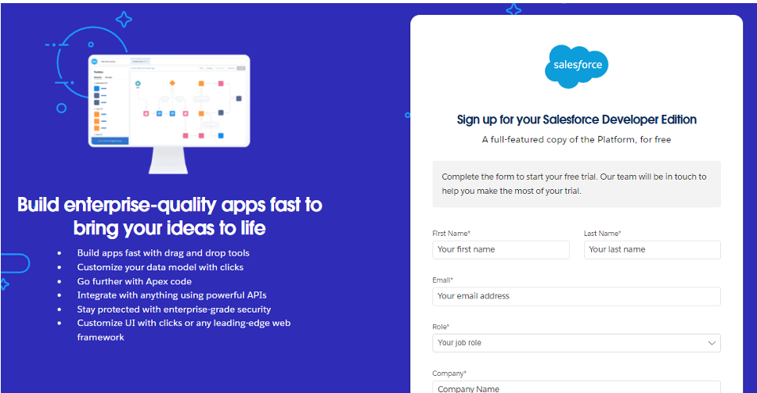
Implementation Steps
The following activities were performed during the initial setup of the project:
- Created a Salesforce Developer Edition account.
- Verified the registered email address.
- Logged into the Salesforce Lightning Experience.
- Accessed the Salesforce Setup page.
- Opened the App Manager from the Setup menu.
- Created a new Lightning Application named AI-Enabled Student Admissions & Support Management System.
- Configured the application description and branding.
- Added the default navigation items including Home, Chatter, Reports, and Dashboards.
- Assigned the application visibility to the System Administrator profile.
- Saved and verified the newly created Lightning Application.
Lightning Application Configuration
Property | Configuration
Application Name | AI-Enabled Student Admissions & Support Management System
Platform | Salesforce Lightning Experience
Application Type | Lightning App
Visible Profile | System Administrator
Navigation Items | Home, Chatter, Reports, Dashboards

Description:
The Salesforce Setup page provides the administrative workspace where application configuration, object management, security settings, automation tools, reports, dashboards, and user management are performed.
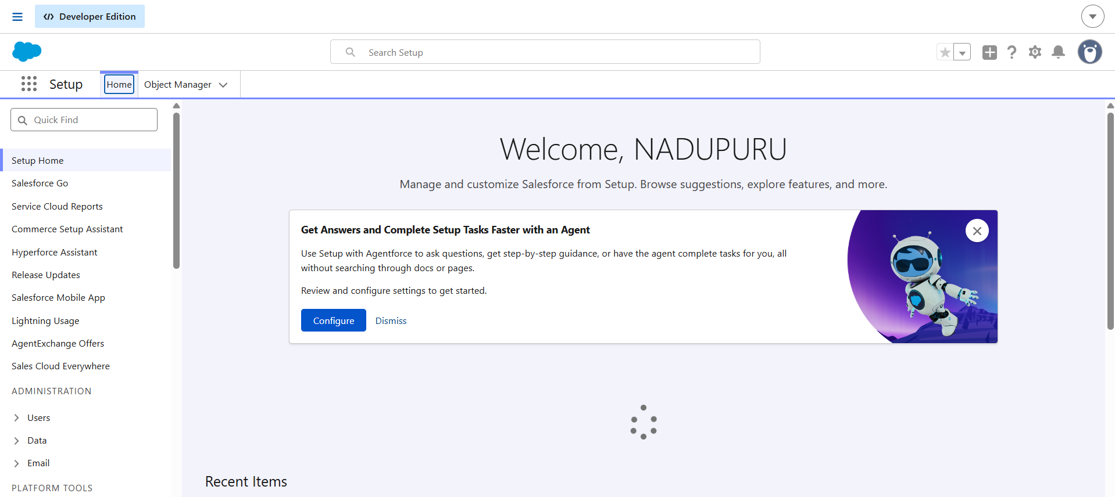

App Manager
Description:
The App Manager displays all Lightning and Classic applications available in the organization. It allows administrators to create, modify, and manage custom applications.
Lightning App Configuration
Description:
This screen shows the configuration page used to define the application name, description, and developer settings before creating the Lightning Application.
Navigation Item Configuration
Description:
The navigation configuration page displays the standard menu items selected for the application. Additional custom object tabs will be added in subsequent milestones.
Created Lightning Application
Description:
The completed Lightning Application after successful creation. The application serves as the centralized workspace for managing student admissions, enrollments, automation, reports, and dashboards.
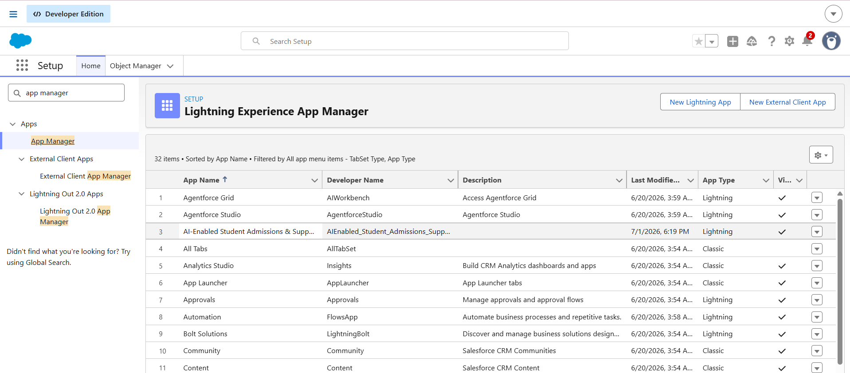
Outcome
The Salesforce Developer Organization was successfully configured, and a dedicated Lightning Application was created for the AI-Enabled Student Admissions & Support Management System. This application provides a centralized environment for implementing all remaining project components, including custom objects, automation, security, reports, dashboards, and AI-powered admission management features.

Milestone 2: Objects Creation
Objective
The objective of this milestone is to create the custom objects required for managing course information and student enrollment details in the AI-Enabled Student Admissions & Support Management System. These objects provide the foundation for storing academic information and supporting the complete student admission process.
Introduction
Salesforce stores data using objects, which are similar to tables in a relational database. Standard objects such as Contact and Opportunity are available by default, while custom objects can be created to meet specific business requirements.
In this project, the standard Contact object is used to manage student information, and the Opportunity object is used to manage admission opportunities. Two additional custom objects, Course and Student Enrollment, were created to store course information and enrollment details respectively.
Objects Used in the Project
Object Name | Object Type | Purpose
Contact | Standard Object | Stores student information
Opportunity | Standard Object | Stores admission details
Course | Custom Object | Stores course information
Student Enrollment | Custom Object | Stores enrollment records

Course Object Configuration
Property | Value
Object Label | Course
Plural Label | Courses
Record Name | Course Name
Data Type | Text
Reports | Enabled
Activities | Enabled
Field History Tracking | Enabled

Student Enrollment Object Configuration
Property | Value
Object Label | Student Enrollment
Plural Label | Student Enrollments
Record Name | Enrollment Number
Data Type | Auto Number
Display Format | ENR-{0000}
Starting Number | 1
Reports | Enabled
Activities | Enabled
Field History Tracking | Enabled

Implementation Steps
The following activities were completed during this milestone:
- Opened Salesforce Setup.
- Navigated to Object Manager.
- Created the Course custom object.
- Configured reports, activities, and field history tracking.
- Created the Student Enrollment custom object.
- Configured the record name as an Auto Number.
- Enabled reporting and activity tracking for the object.
- Verified both objects in Object Manager.
Object Manager
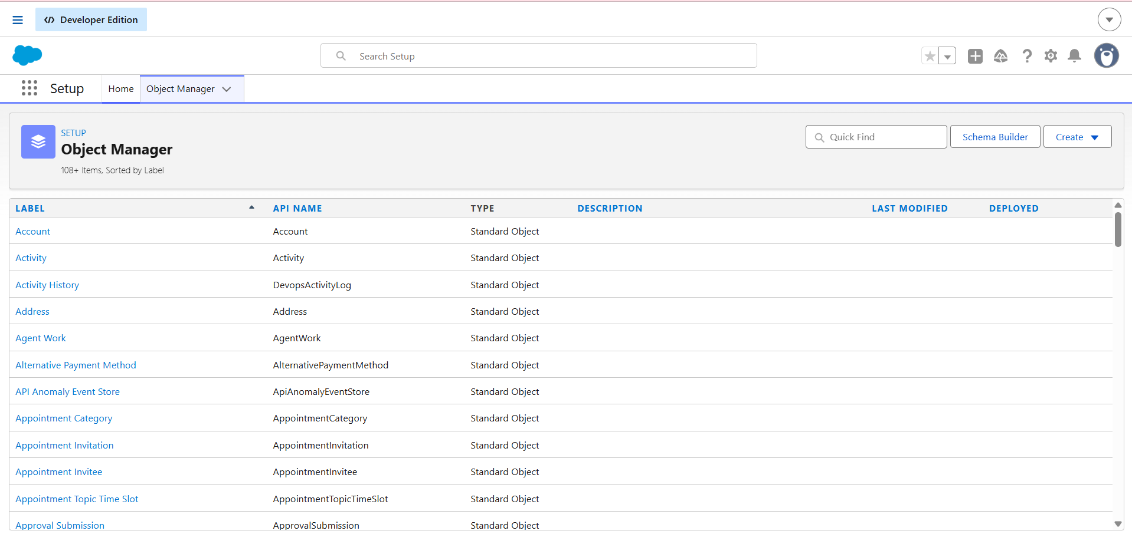

Description
The Object Manager provides access to all standard and custom objects available in the Salesforce organization. It is used to create and manage the data model of the application.
Course Object Configuration
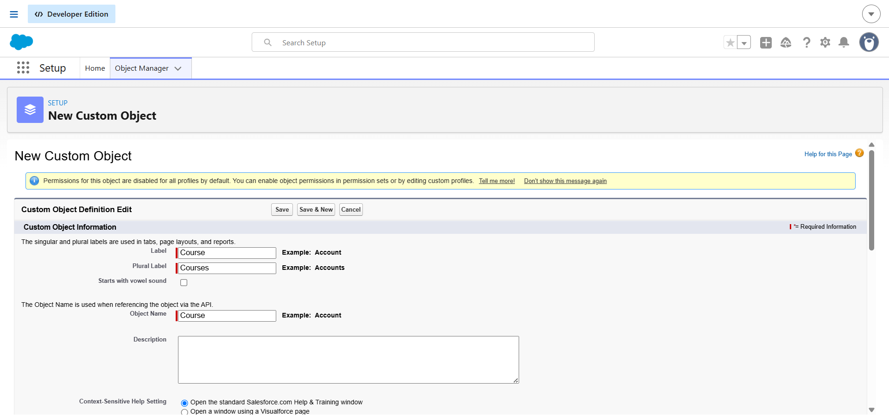
Description
This screenshot shows the configuration details of the Course custom object, including its object label, record name, and enabled features such as reports, activities, and field history tracking.

Course Object Details
Description
The Course object was successfully created and is now available in the Salesforce organization for storing course-related information.

Student Enrollment Object Configuration
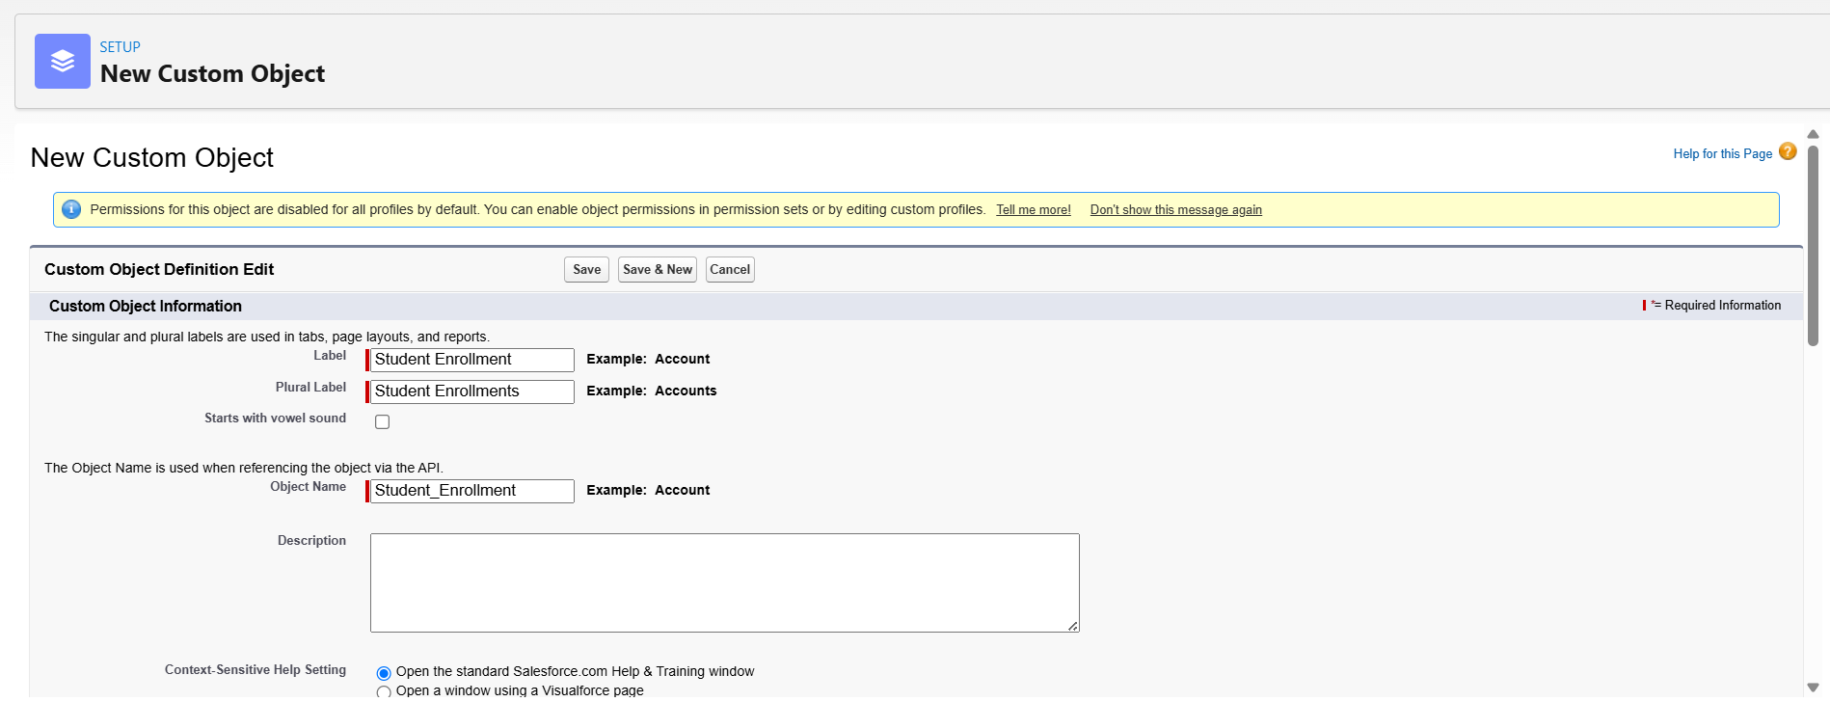
Description
This screenshot displays the configuration of the Student Enrollment custom object with the Auto Number record name format and enabled reporting features.
Object Manager after Object Creation
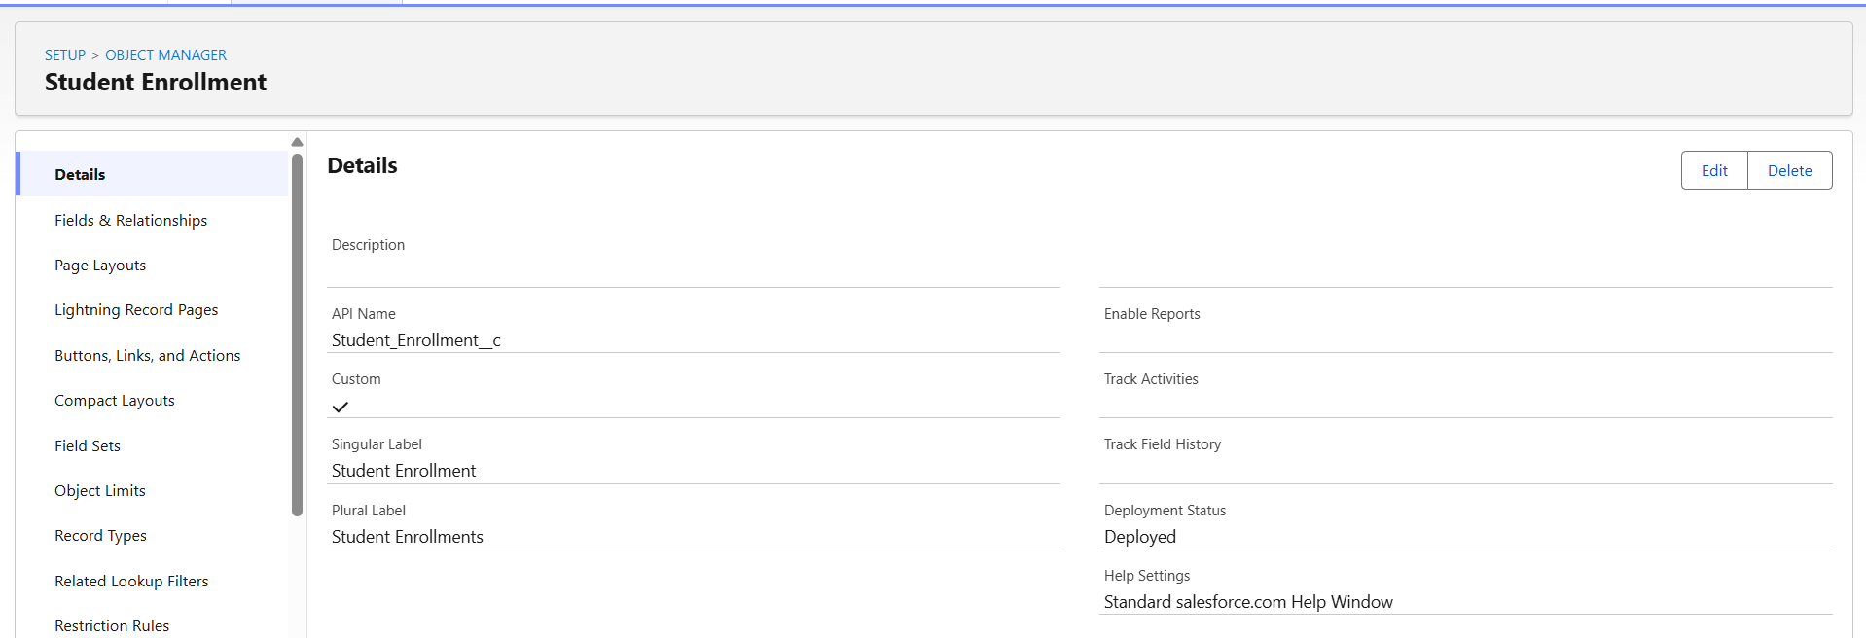
Description
The Object Manager displaying both newly created custom objects, Course and Student Enrollment, confirming their successful creation.
Outcome
The required custom objects were successfully created in Salesforce. These objects establish the core data model for the AI-Enabled Student Admissions & Support Management System and will be used in subsequent milestones to create fields, relationships, automation, and security configurations.

Milestone 3 – Tabs
Objective
The objective of this milestone is to create custom tabs for the custom objects developed in the previous milestone. Tabs provide users with easy navigation and quick access to records stored within custom objects through the Lightning Application.
Introduction
Salesforce Tabs provide a user-friendly interface to access object records. Creating tabs for custom objects ensures that users can easily create, view, edit, and manage records directly from the Lightning Application. In this project, tabs were created for the Course and Student Enrollment objects to improve usability and navigation.
Tabs Created
Tab Name | Object
Course | Course
Student Enrollment | Student Enrollment

Implementation Steps
- Navigated to the Tabs configuration page in Salesforce Setup.
- Created a custom tab for the Course object.
- Selected an appropriate tab style.
- Enabled tab visibility for the System Administrator profile.
- Added the tab to the AI-Enabled Student Admissions & Support Management System Lightning App.
- Repeated the same process for the Student Enrollment object.
- Verified that both tabs were successfully displayed in the Lightning Application.
Custom Tabs Configuration
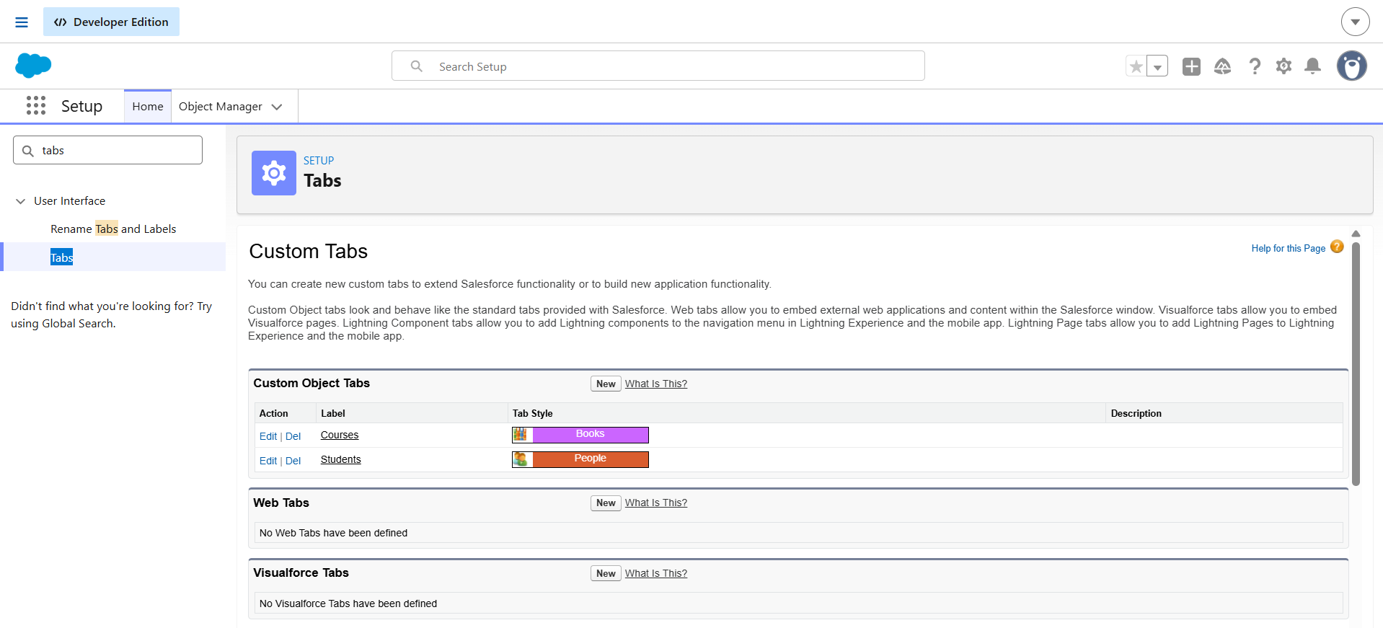
Description:
The custom tabs for the Course and Student Enrollment objects were successfully created and configured, allowing users to access these objects directly from the Lightning Application.
Lightning Application Navigation
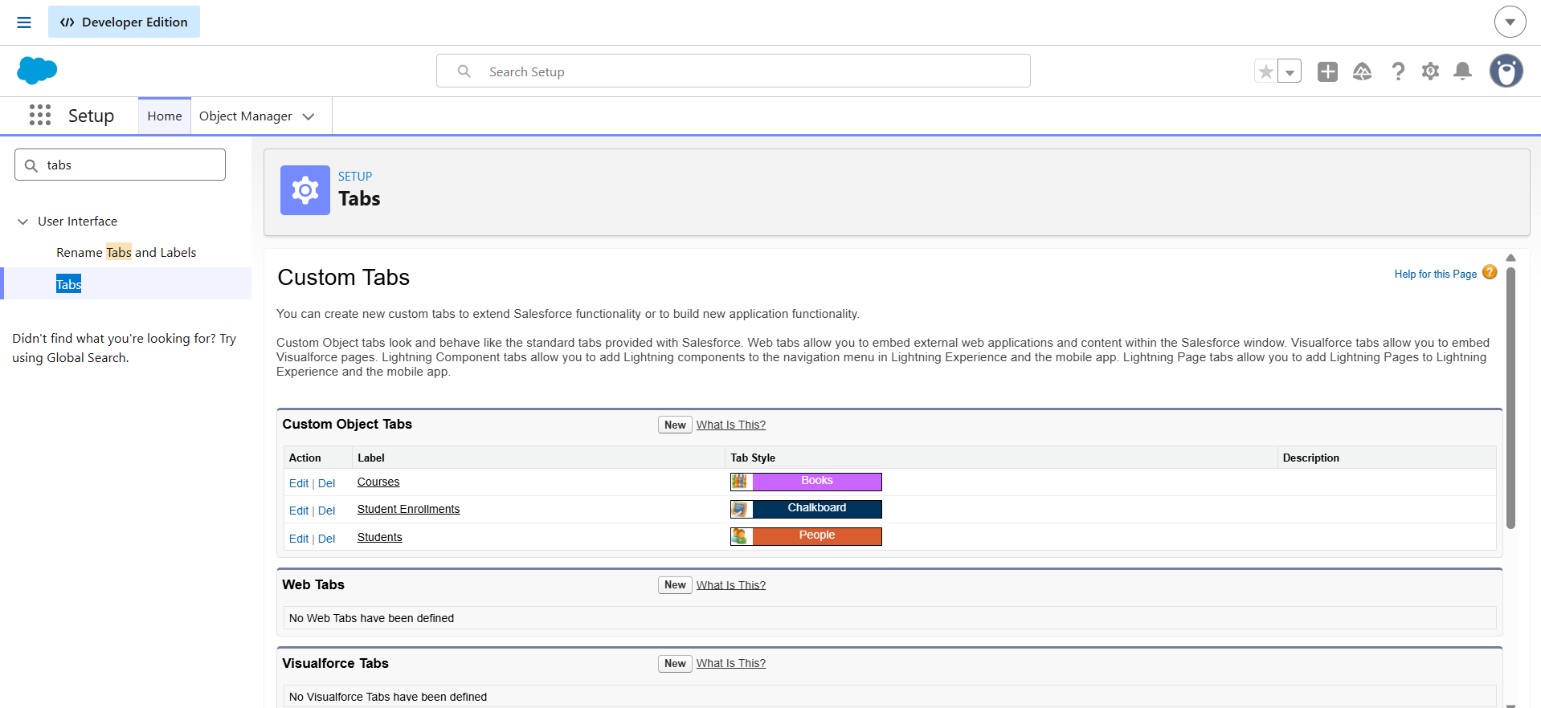
Description:
The Lightning Application displaying the newly created Course and Student Enrollment tabs, providing centralized access to all admission management components.
Outcome
The custom tabs for the Course and Student Enrollment objects were successfully created and integrated into the Lightning Application. These tabs enhance user navigation and provide direct access to the application's core data objects.
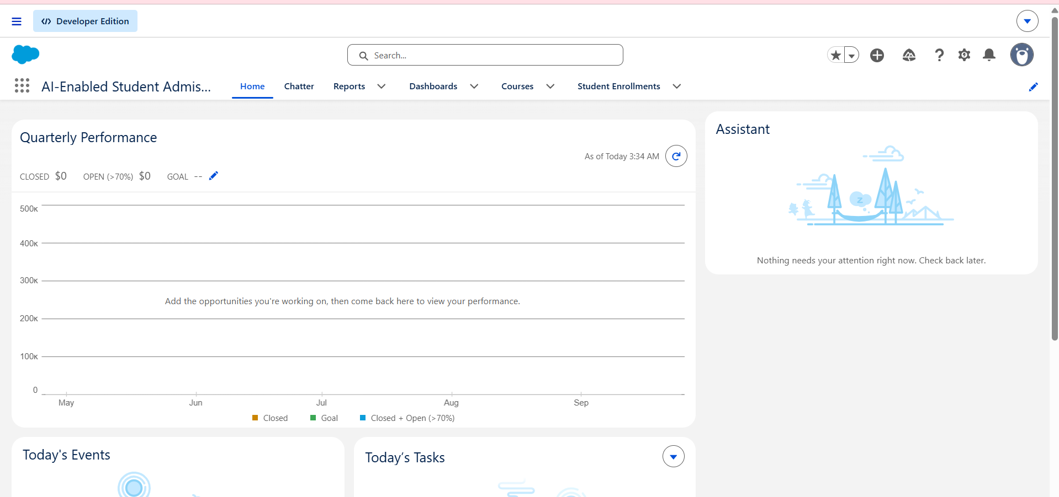

Milestone 4: Fields & Relationships
Objective
The objective of this milestone is to extend the standard Contact object with custom fields required to manage student information effectively. These fields enable the system to uniquely identify students, record their educational qualifications, and monitor their admission status throughout the enrollment process.
Introduction
The Contact object is used as the primary object for storing student information in the AI-Enabled Student Admissions & Support Management System. Additional custom fields were created to capture student-specific details that are not available in the standard Salesforce Contact object.

Course__c
The Course__c object is a custom object developed to maintain information about the courses offered by the institution. It stores course-related details such as course code, category, fee, duration, status, and capacity. This object acts as the master record for all available courses and is linked to student enrollment records.

Fields in Course__c
Field 1: Course Code
- Data Type: Text
- Field Label: Course Code
- Field Name: Auto Populates
- Required: Check the box
- Click: Next → Next → Save & New
Field 2: Course Category
- Data Type: Picklist
- Field Label: Course Category
- Field Name: Auto Populates
- Values: Technical, Non-Technical
- Required: Check the box
- Click: Next → Next → Save & New
Field 3: Course Fee
- Data Type: Currency
- Field Label: Course Fee
- Field Name: Auto Populates
- Required: Check the box
- Click: Next → Next → Save & New
Field 4: Course Duration
- Data Type: Number
- Field Label: Course Duration
- Field Name: Auto Populates
- Required: Check the box
- Click: Next → Next → Save & New
Field 5: Course Status
- Data Type: Picklist
- Field Label: Course Status
- Field Name: Auto Populates
- Values: Active, Inactive
- Required: Check the box
- Click: Next → Next → Save & New
Field 6: Capacity
- Data Type: Number
- Field Label: Capacity
- Field Name: Auto Populates
- Required: Check the box
- Click: Next → Next → Save
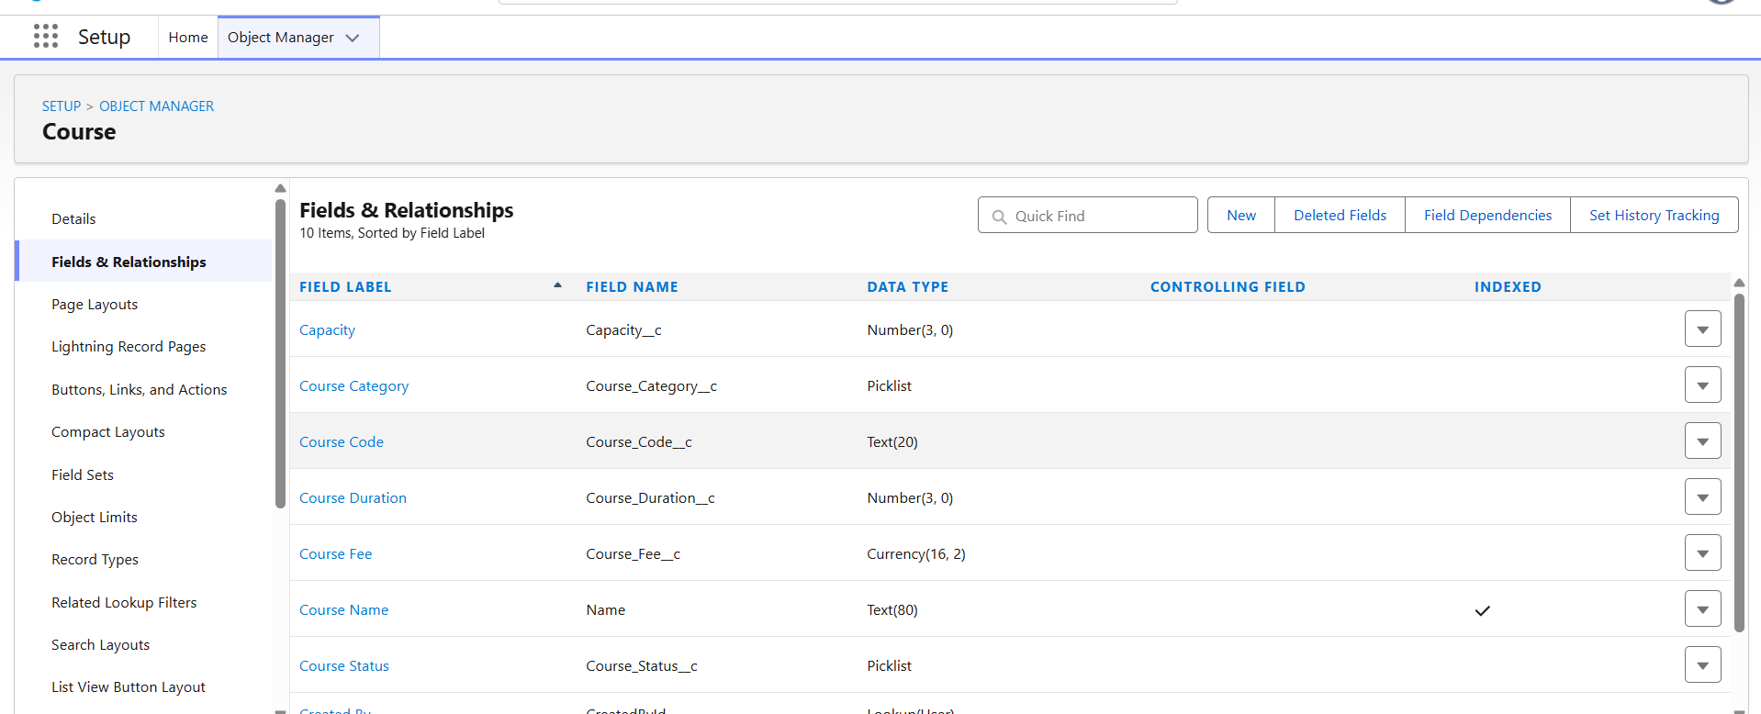

Student_Enrollment__c
The Student_Enrollment__c object is a custom object used to manage student enrollment details. It establishes the relationship between students and courses while tracking enrollment status, approvals, payments, discounts, and the final payable amount. This object serves as the central component of the Student Admission Management System.

Fields in Student_Enrollment__c
Field 1: Student
- Data Type: Master-Detail Relationship (Contact)
- Field Label: Student
- Field Name: Auto Populates
- Related To: Contact
- Required: Yes (Automatically)
- Click: Next → Next → Save & New

Field 2: Course
- Data Type: Master-Detail Relationship (Course__c)
- Field Label: Course
- Field Name: Auto Populates
- Related To: Course__c
- Required: Yes (Automatically)
- Click: Next → Next → Save & New
Field 3: Enrollment Date
- Data Type: Date
- Field Label: Enrollment Date
- Field Name: Auto Populates
- Required: Check the box
- Click: Next → Next → Save & New
Field 4: Discount Percentage
- Data Type: Percent
- Field Label: Discount Percentage
- Field Name: Auto Populates
- Required: Leave Unchecked
- Click: Next → Next → Save & New
Field 5: Final Payable Amount
- Data Type: Formula (Currency)
- Field Label: Final Payable Amount
- Field Name: Auto Populates
- Formula: Course__r.Course_Fee__c * (1 - (Discount__c / 100))
- Click: Check Syntax → Next → Next → Save & New
Field 6: Enrollment Status
- Data Type: Picklist
- Field Label: Enrollment Status
- Field Name: Auto Populates
- Values: Draft, Pending Approval, Approved
- Required: Check the box
- Click: Next → Next → Save & New
Field 7: Approval Status
- Data Type: Picklist
- Field Label: Approval Status
- Field Name: Auto Populates
- Values: Pending, Approved, Rejected
- Required: Check the box
- Click: Next → Next → Save & New
Field 8: Payment Status
- Data Type: Picklist
- Field Label: Payment Status
- Field Name: Auto Populates
- Values: Paid, Pending
- Required: Check the box
- Click: Next → Next → Save
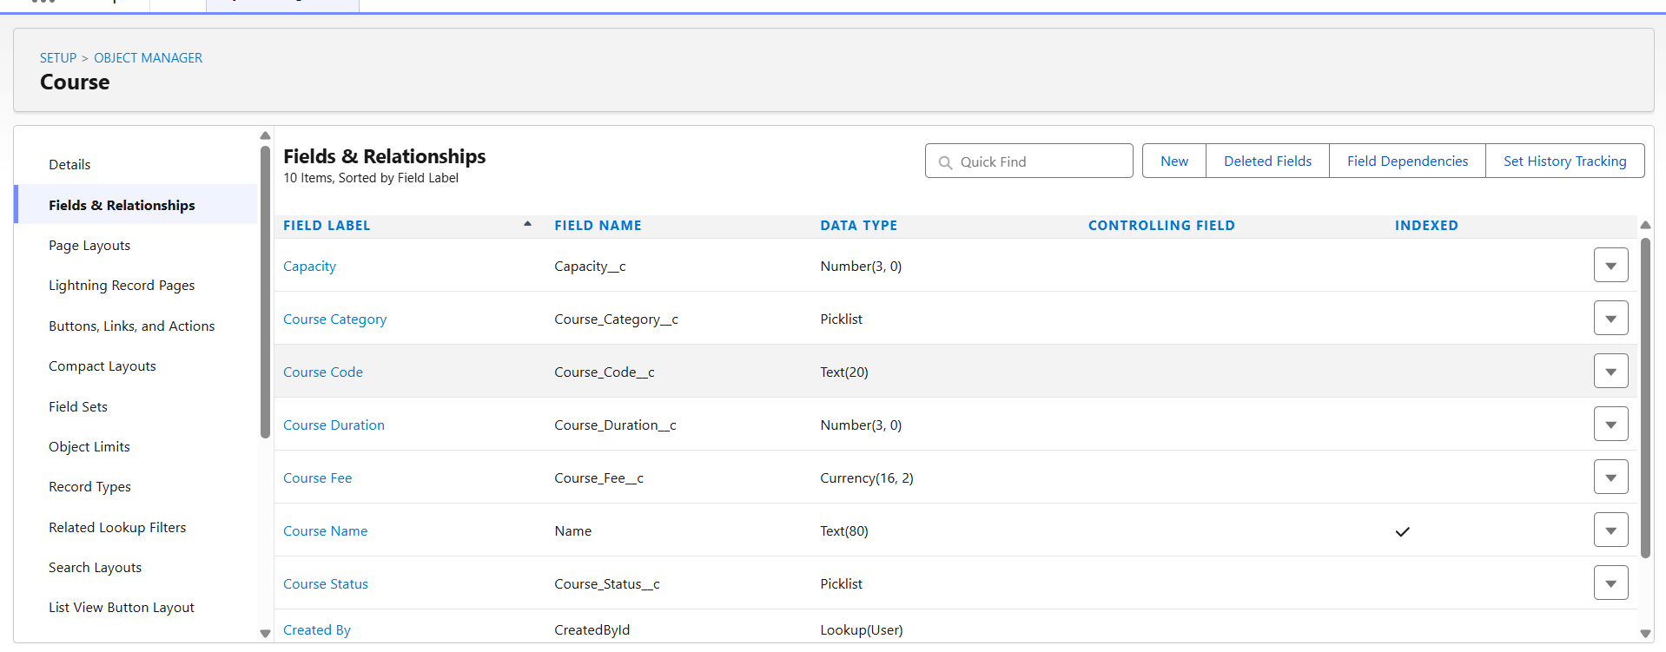
Contact
The Contact object is a standard Salesforce object used to maintain student information. It stores the personal and academic details of students who apply for admission and serves as the primary record linked to enrollment and admission processes.
Fields in Contact
Field 1: Student ID
- Data Type: Text
- Field Label: Student ID
- Field Name: Auto Populates
- Required: Check the box
- Click: Next → Next → Save & New
Field 2: Education Level
- Data Type: Picklist
- Field Label: Education Level
- Field Name: Auto Populates
- Values: Intermediate, Diploma, Undergraduate, Postgraduate
- Required: Check the box
- Click: Next → Next → Save & New
Field 3: Student Status
- Data Type: Picklist
- Field Label: Student Status
- Field Name: Auto Populates
- Values: New, Active, Inactive, Admitted
- Required: Check the box
- Click: Next → Next → Save
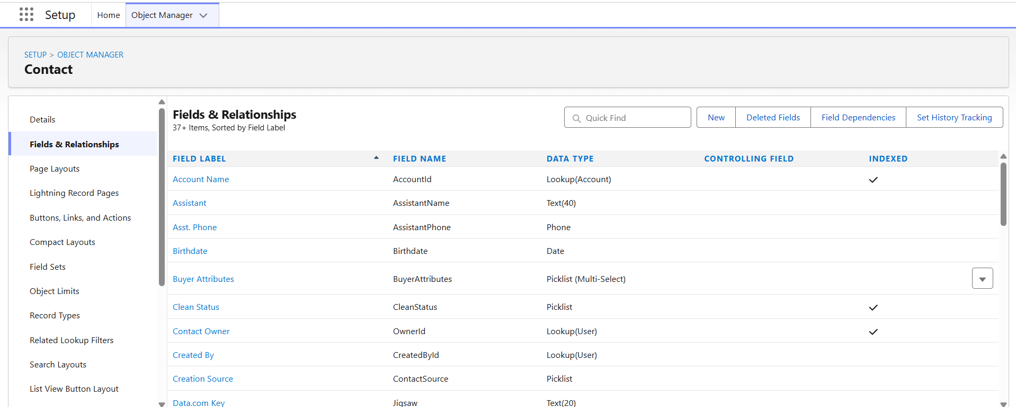

Opportunity
The Opportunity object is used to manage the student admission process. Each opportunity represents an admission application and tracks its progress, counselor assignment, payment details, and expected course start date.

Fields in Opportunity
Field 1: Admission Stage
- Data Type: Picklist
- Field Label: Admission Stage
- Field Name: Auto Populates
- Values: Inquiry, Application Submitted, Under Review, Approved, Rejected
- Required: Check the box
- Click: Next → Next → Save & New
Field 2: Expected Start Date
- Data Type: Date
- Field Label: Expected Start Date
- Field Name: Auto Populates
- Required: Check the box
- Click: Next → Next → Save & New
Field 3: Payment Status
- Data Type: Picklist
- Field Label: Payment Status
- Field Name: Auto Populates
- Values: Pending, Paid
- Required: Check the box
- Click: Next → Next → Save & New
Field 4: Counselor Assigned
- Data Type: Lookup (User)
- Field Label: Counselor Assigned
- Field Name: Auto Populates
- Related To: User
- Required: Leave Unchecked
- Click: Next → Next → Save & New
Field 5: Total Course Fee
- Data Type: Currency
- Field Label: Total Course Fee
- Field Name: Auto Populates
- Required: Check the box
- Click: Next → Next → Save
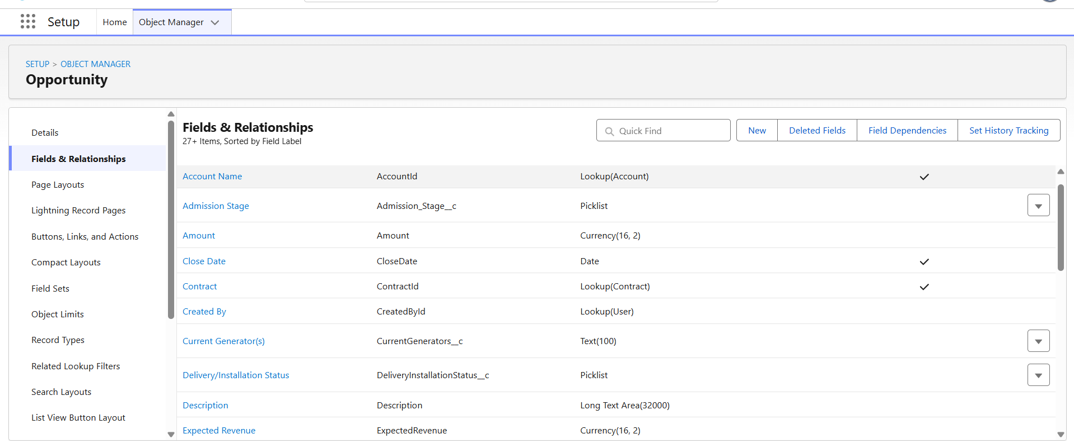
Implementation Steps
- Opened the Contact object from Object Manager.
- Navigated to the Fields & Relationships section.
- Created the fields using the given data type.
- Saved the fields and verified their successful creation.
Outcome
The Contact object was successfully customized with the required student-related fields. These fields provide a structured way to identify students, record educational qualifications, and monitor their admission status within the application.

Milestone 5 – Validation Rules
Objective
The objective of this milestone is to implement validation rules that ensure only valid and complete data is entered into the AI-Enabled Student Admissions & Support Management System. Validation rules improve data quality by preventing users from saving incorrect or incomplete records.
Introduction
Validation Rules are declarative Salesforce features used to enforce business rules during record creation and updates. When a validation rule evaluates to TRUE, Salesforce prevents the record from being saved and displays an error message to the user. In this project, validation rules were implemented to maintain accurate student admission and enrollment information.

Validation Rules
Validation Rules are used in Salesforce to maintain data integrity by preventing users from saving records that do not satisfy specific business requirements. In this project, validation rules were implemented on the Course__c, Opportunity, and Student_Enrollment__c objects to ensure accurate and consistent data entry.

Activity 1: Create a Validation Rule on Course__c Object
Validation Rule Name : Course_Capacity_Validation
Object : Course__c
Objective
To ensure that the course capacity entered is greater than zero. This prevents users from creating courses with invalid or zero capacity.
Formula: Capacity__c <= 0
Error Message: Course Capacity must be greater than zero.
Error Location
Field: Capacity
Outcome
When a user enters a value less than or equal to zero for the course capacity, Salesforce displays an error message and prevents the record from being saved.
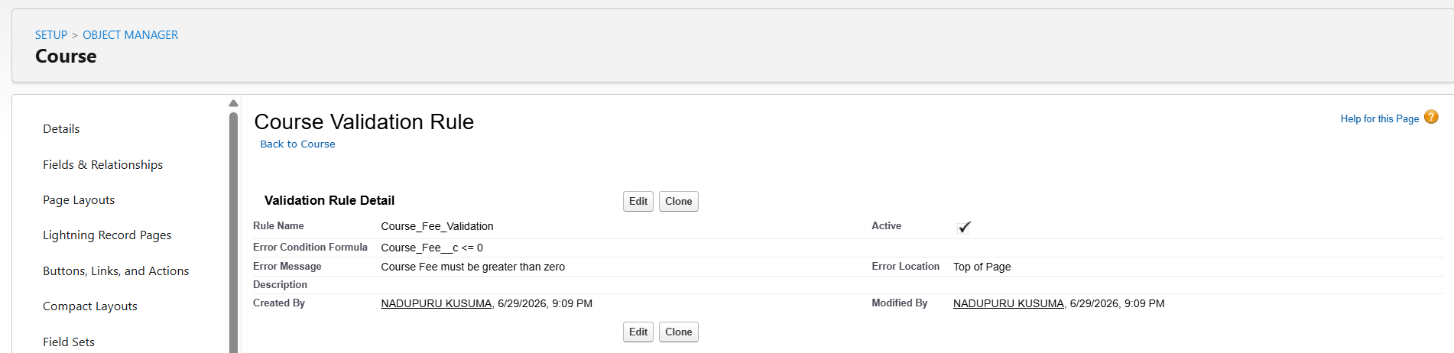
Activity 2: Create a Validation Rule on Opportunity Object
Validation Rule Name
Expected_Start_Date_Validation
Object: Opportunity
Objective : To prevent users from selecting an expected course start date that is earlier than the current date.
Formula: Expected_Start_Date__c < TODAY()
Error Message: Expected Start Date cannot be in the past.
Field: Expected Start Date
Outcome
If a past date is entered as the expected start date, Salesforce displays an error message and blocks the record from being saved until a valid future date is selected.
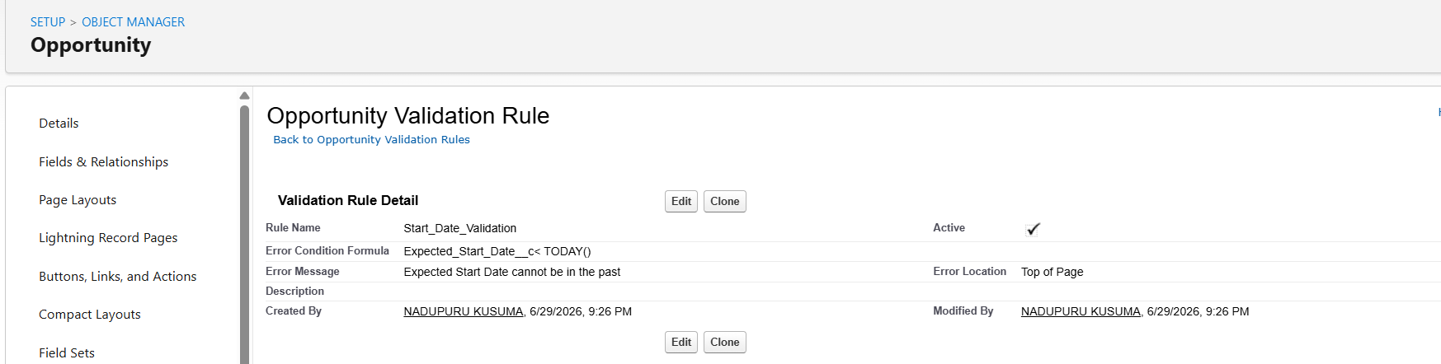
Activity 3: Create a Validation Rule on Student_Enrollment__c Object
Validation Rule Name
Discount_Percentage_Validation
Object: Student_Enrollment__c
Objective: To ensure that the discount percentage entered for a student enrollment remains within the valid range of 0% to 100%.
Formula : OR(Discount__c < 0,Discount__c > 100)
Error Message: Discount Percentage must be between 0 and 100.
Error Location
Field: Discount Percentage
Outcome
If the user enters a discount value below 0% or above 100%, Salesforce prevents the record from being saved and displays the appropriate validation message. This ensures that only valid discount percentages are applied during the enrollment process.
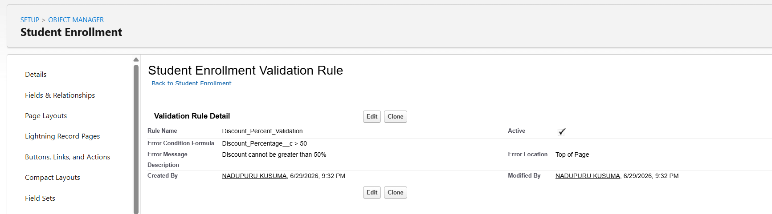
Implementation Steps
- Opened the required object in Object Manager.
- Navigated to the Validation Rules section.
- Created a validation rule using a formula expression.
- Specified an appropriate error message and error location.
- Saved and activated the validation rule.
- Tested the validation rule by creating sample records with invalid values.
Outcome
The validation rules implemented in this project improve data quality by enforcing business constraints at the time of record creation or update. They help prevent invalid course capacities, incorrect admission dates, and unrealistic discount percentages, thereby ensuring reliable and consistent data across the Student Admission Management System.

Milestone 6 – Approval Process
Objective
The objective of this milestone is to implement an Approval Process for high-discount student enrollments in the AI-Enabled Student Admissions & Support Management System. This approval workflow ensures that student enrollments with discounts beyond the allowed limit are reviewed and approved by the Admission Manager before the enrollment is finalized.
Introduction
An Approval Process in Salesforce automates the review and approval of business records based on predefined conditions. It routes records to designated approvers, locks records during review, and performs actions upon approval or rejection.
In this project, an approval process was created on the Student Enrollment object to manage enrollments that receive high discounts. Whenever the discount percentage exceeds the specified limit, the enrollment record is automatically submitted to the Admission Manager for approval.

Approval Process Details
Property | Value
Approval Process Name | High Discount Student Enrollment Approval
Object | Student Enrollment
Entry Criteria | Discount Percentage > 20%
Approver | Admission Manager
Initial Submission Action | Lock Record
Final Approval Action | Update Approval Status to Approved
Final Rejection Action | Update Approval Status to Rejected
Record Unlock | Enabled after Approval/Rejection
Status | Active
Approval Workflow
Stage | Description
Record Submission | Student Enrollment record is submitted for approval.
Entry Criteria Check | Salesforce verifies whether the discount percentage is greater than 20%.
Approval Request | Approval request is sent to the Admission Manager.
Manager Review | The Admission Manager reviews the enrollment details.
Approval | Approval Status is updated to Approved.
Rejection | Approval Status is updated to Rejected.

Implementation Steps
The following activities were completed during this milestone:
- Opened Salesforce Setup.
- Navigated to Approval Processes.
- Selected the Student Enrollment object.
- Created a new Approval Process using the Standard Setup Wizard.
- Configured the approval process details.
- Defined the entry criteria based on the Discount Percentage field.
- Assigned the Admission Manager as the approver.
- Configured the Initial Submission Actions.
- Configured the Final Approval Actions.
- Configured the Final Rejection Actions.
- Saved the Approval Process.
- Activated the Approval Process.
- Verified the approval workflow by submitting a Student Enrollment record for approval.
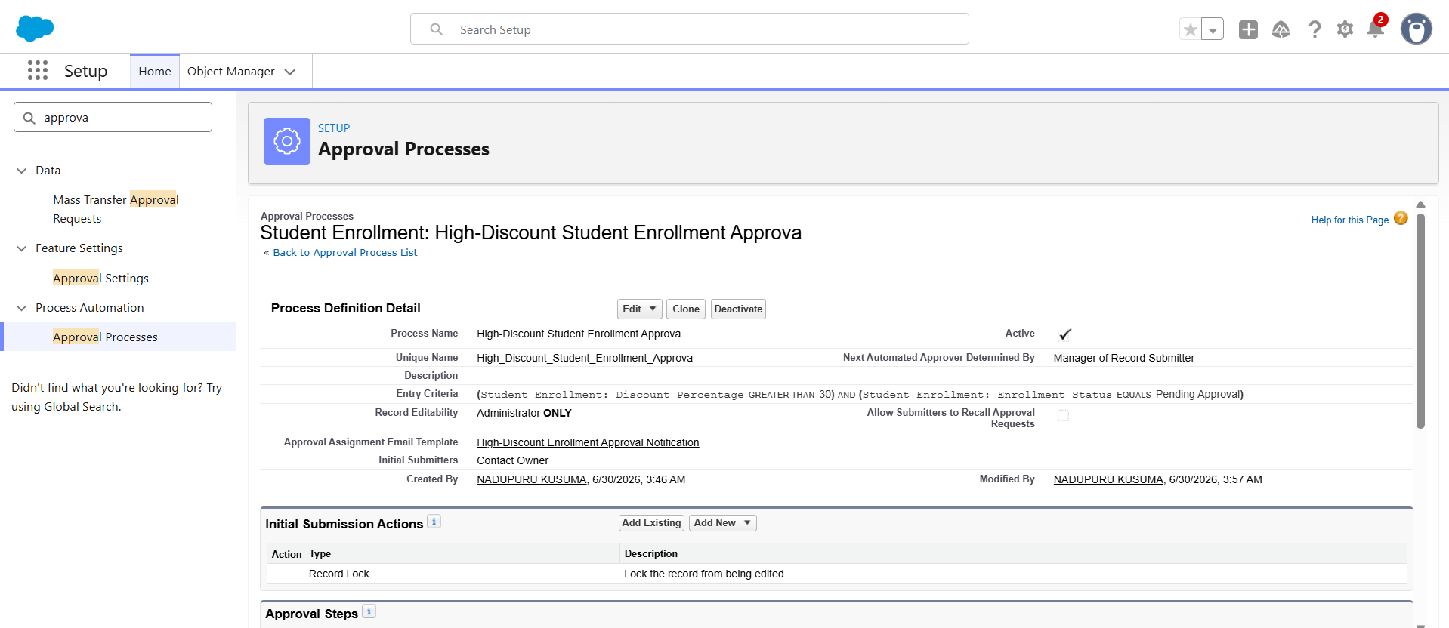
Outcome
The Approval Process was successfully implemented on the Student Enrollment object. Student enrollments with discounts exceeding the defined threshold are automatically routed to the Admission Manager for approval. The workflow locks records during the approval cycle, updates the approval status based on the manager's decision, and ensures that high-discount enrollments are processed in a controlled and transparent manner. This automation improves data integrity, enforces organizational policies, and reduces manual effort in the student admission process.

Milestone 7 – Email Templates
Objective
The objective of this milestone is to create reusable Email Templates for the AI-Enabled Student Admissions & Support Management System. These templates automate communication with students and admission counselors by sending standardized email notifications during different stages of the admission process.
Introduction
Email Templates in Salesforce provide a standardized way to send emails with dynamic data. They reduce manual effort, maintain consistency in communication, and improve the efficiency of the admission process. Templates can be used in workflows, flows, approval processes, and other automation tools to notify students and staff automatically.
In this project, email templates were created to inform students and counselors about application submission, approval status, payment confirmation, and enrollment updates.
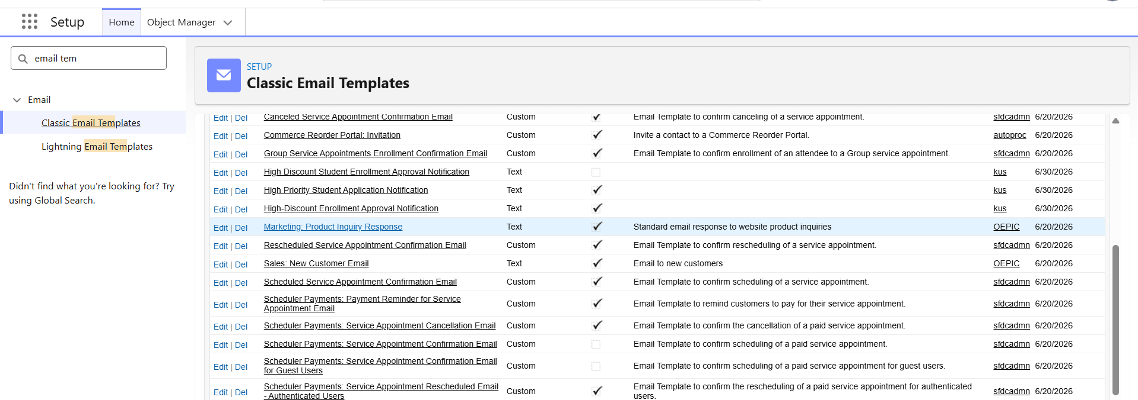

Email Templates Created
Template Name | Purpose | Recipient
Student Admission Confirmation | Confirms successful submission of the admission application. | Student
Enrollment Approval Notification | Notifies the student that the enrollment has been approved. | Student
Enrollment Rejection Notification | Informs the student that the enrollment request has been rejected. | Student
Payment Confirmation | Confirms successful payment of the course fee. | Student
Counselor Notification | Notifies the assigned counselor about a new student enrollment or approval request. | Admission Counselor

Email Template Configuration
Property | Value
Template Type | Lightning Email Template
Folder | Public Email Templates
Related Object | Student Enrollment / Contact
Available for Use | Enabled
Merge Fields | Student Name, Course Name, Enrollment Status, Payment Status, Discount Percentage

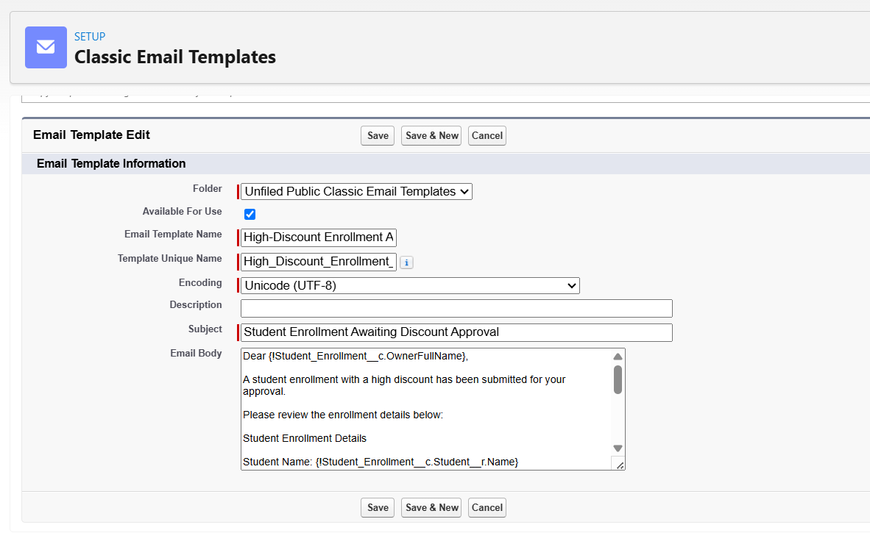

Implementation Steps
The following activities were completed during this milestone:
- Opened Salesforce Setup.
- Navigated to Email Templates.
- Clicked New Email Template.
- Entered the Template Name and Description.
- Selected the appropriate Related Entity Type.
- Designed the email subject and body using merge fields.
- Saved the email template.
- Repeated the process to create all required templates.
- Verified that the templates were available for use in Flows and Approval Processes.
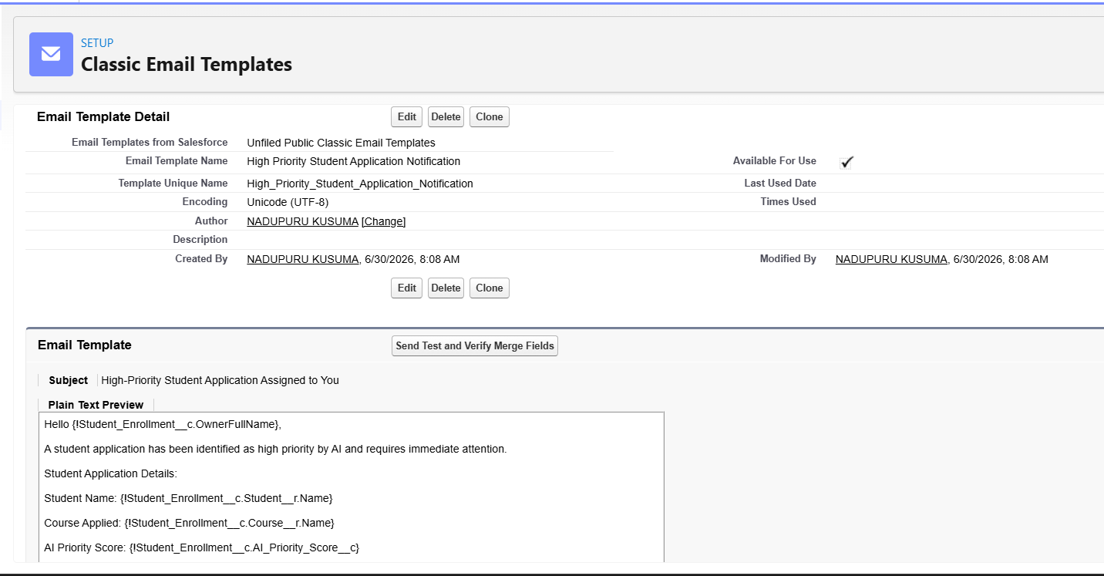
Outcome
The required email templates were successfully created in Salesforce. These templates provide consistent and automated communication throughout the student admission process. They reduce manual effort, improve response time, ensure professional communication with students and counselors, and seamlessly integrate with Salesforce Flows and Approval Processes to automate notifications.

Milestone 8 – Email Alerts
Objective
The objective of this milestone is to create Email Alerts in the AI-Enabled Student Admissions & Support Management System. Email Alerts automate the process of sending notifications to students, admission counselors, and managers based on different events such as enrollment approval, rejection, payment confirmation, and high-priority applications.

Introduction
Email Alerts are a Salesforce automation feature that sends predefined email templates to selected recipients when specific conditions are met. They eliminate manual communication, improve response time, and ensure that stakeholders receive timely updates throughout the admission process.
In this project, Email Alerts were configured to work with Flows and Approval Processes to automatically notify students and counselors whenever important actions occur.
Email Alerts Created
Email Alert Name | Related Object | Email Template | Recipient
Student Admission Confirmation | Student Enrollment | Student Admission Confirmation | Student
Enrollment Approval Alert | Student Enrollment | Enrollment Approval Notification | Student
Enrollment Rejection Alert | Student Enrollment | Enrollment Rejection Notification | Student
Payment Confirmation Alert | Student Enrollment | Payment Confirmation | Student
Counselor Notification Alert | Student Enrollment | Counselor Notification | Admission Counselor

Email Alert Configuration
Property | Value
Object | Student Enrollment
Email Template | Selected Lightning Email Template
Recipient Type | Email Field / User / Related Contact
Sender | Current User / Organization-Wide Email Address
Status | Active

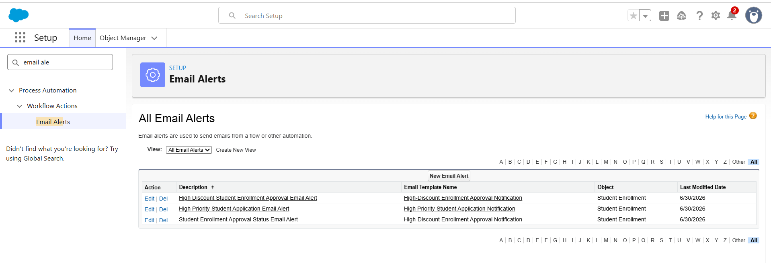
Implementation Steps
The following activities were completed during this milestone:
- Opened Salesforce Setup.
- Searched for Email Alerts in the Quick Find box.
- Clicked New Email Alert.
- Selected the Student Enrollment object.
- Entered the Email Alert Name.
- Selected the appropriate Lightning Email Template.
- Chose the required recipients (Student, Admission Counselor, or Manager).
- Saved the Email Alert.
- Repeated the process to create all required Email Alerts.
- Linked the Email Alerts to the corresponding Flows and Approval Processes.
- Tested the Email Alerts to verify that notifications were sent successfully.
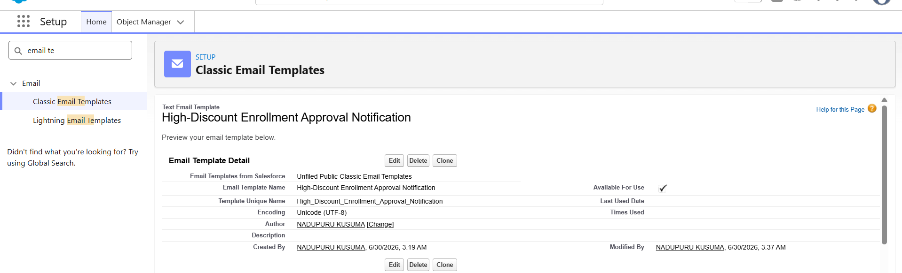
Outcome
The Email Alerts were successfully created and integrated with Salesforce automation. Notifications are now sent automatically to students, admission counselors, and managers whenever predefined events occur. This automation improves communication, reduces manual effort, ensures timely updates, and enhances the overall efficiency of the Student Admissions & Support Management System.

Milestone 9 – Declarative Automation (Flows)
Objective
The objective of this milestone is to automate the student admission and enrollment process using Salesforce Flow Builder. Declarative automation eliminates repetitive manual tasks by automatically performing actions based on predefined business rules, thereby improving efficiency, accuracy, and consistency within the AI-Enabled Student Admissions & Support Management System.
Introduction
Salesforce Flow Builder is a powerful declarative automation tool that enables administrators to automate business processes without writing Apex code. Record-Triggered Flows execute automatically whenever a record is created or updated and can perform various operations such as updating records, sending email notifications, creating tasks, and invoking approval processes.
In this project, Record-Triggered Flows were developed to automate important admission activities, including notifying admission counselors about high-priority student applications and updating enrollment records based on changes in approval and payment status.
Flows Implemented
The following flows were created during this milestone:
Flow Name | Purpose
High Priority Student Application Notification | Automatically notifies the assigned Admission Counselor when the AI Priority Score is greater than or equal to 80.
Student Enrollment Status Update | Automatically updates enrollment-related information whenever the Student Enrollment record is modified.
Approval Status Notification | Sends notification emails after the enrollment record is approved or rejected.

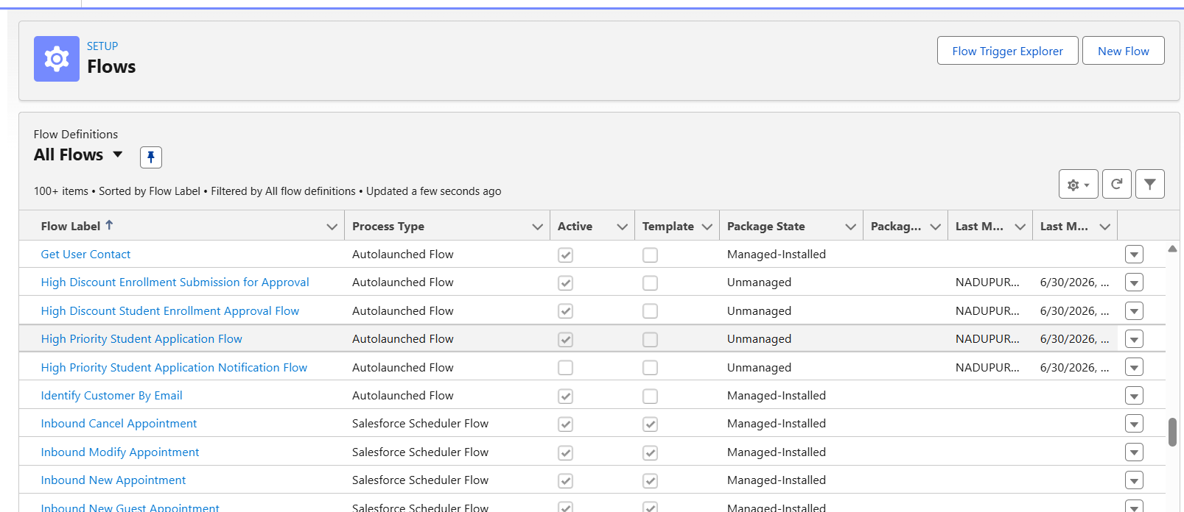

Implementation Steps
The following activities were completed during this milestone:
- Opened Salesforce Setup.
- Navigated to Flow Builder.
- Clicked New Flow.
- Selected Record-Triggered Flow.
- Chose the Student Enrollment object as the trigger object.
- Configured the flow to execute when a record is created or updated.
- Defined the entry conditions based on the required business requirements.
- Added Decision elements to evaluate the record conditions.
- Configured Update Records elements to update enrollment details automatically.
- Added Email Alert actions to notify students and admission counselors.
- Saved the flow with an appropriate label and API name.
- Activated the flow.
- Tested the automation using sample Student Enrollment records.
- Verified that the flow executed successfully and performed the expected actions.
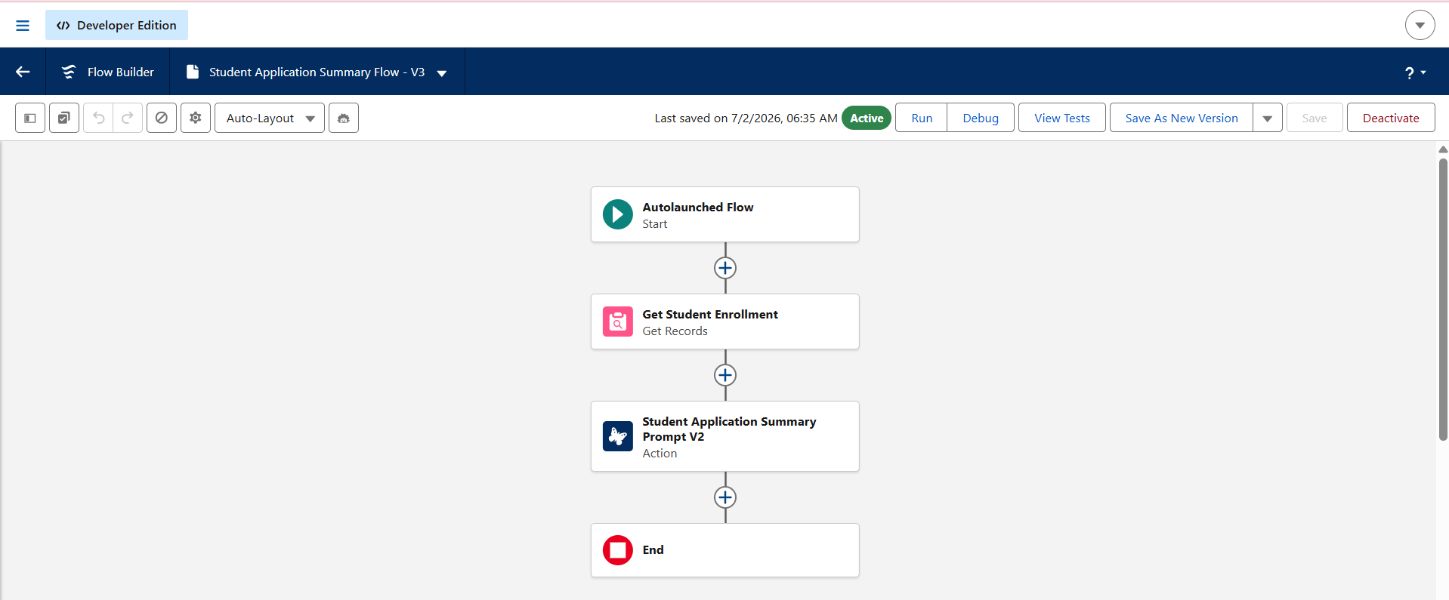
Outcome
The declarative automation was successfully implemented using Salesforce Flow Builder. The developed flows automatically execute business processes whenever Student Enrollment records are created or updated. The automation notifies counselors about high-priority applications, updates enrollment information, and sends email notifications without manual intervention. As a result, the admission process became more efficient, data consistency was improved, response time was reduced, and the overall workflow of the Student Admissions & Support Management System was streamlined.

Milestone 10 – Agentforce AI
Objective
The objective of this milestone is to implement Salesforce Agentforce AI in the AI-Enabled Student Admissions & Support Management System. Agentforce AI assists admission counselors by analyzing student enrollment records, generating application summaries, assessing enrollment risks, and recommending approval decisions based on the available student data.
Introduction
Salesforce Agentforce AI is an intelligent AI-powered platform that enables organizations to automate complex business processes using conversational AI and prompt-driven actions. It integrates seamlessly with Salesforce data and provides users with contextual recommendations, summaries, and intelligent insights without requiring custom code.
In this project, Agentforce AI was configured to support the student admission process by providing counselors with AI-generated summaries, enrollment risk analysis, and approval recommendations. This reduces manual effort, improves decision-making, and enhances the overall efficiency of the admission workflow.
Agent Configuration
The following Agentforce AI components were configured during this milestone:
Component | Description
AI Agent | Admission Support Agent
Primary Object | Student Enrollment
User Role | Admission Manager and Admission Counselor
Prompt Templates | Generate Student Application Summary, Analyze Enrollment Risk, Recommend Approval Decision
AI Actions | Generate Summary, Risk Analysis, Approval Recommendation
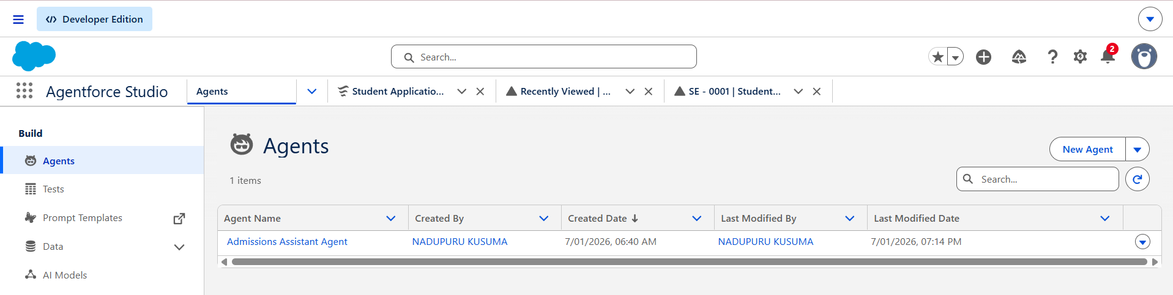

Implementation Steps
The following activities were completed during this milestone:
- Opened Salesforce Setup.
- Navigated to Agentforce.
- Created a new AI Agent for the Student Admissions & Support Management System.
- Configured the Agent Name and Description.
- Assigned the appropriate user roles and permissions.
- Connected the agent to the Student Enrollment object.
- Created Prompt Templates for AI-generated responses.
- Added AI Actions to perform admission-related tasks.
- Configured the agent to use Salesforce data for generating intelligent responses.
- Saved the Agent configuration.
- Activated the AI Agent.
- Tested the agent using sample Student Enrollment records.
- Verified that the agent successfully generated summaries, analyzed enrollment risks, and recommended approval decisions.

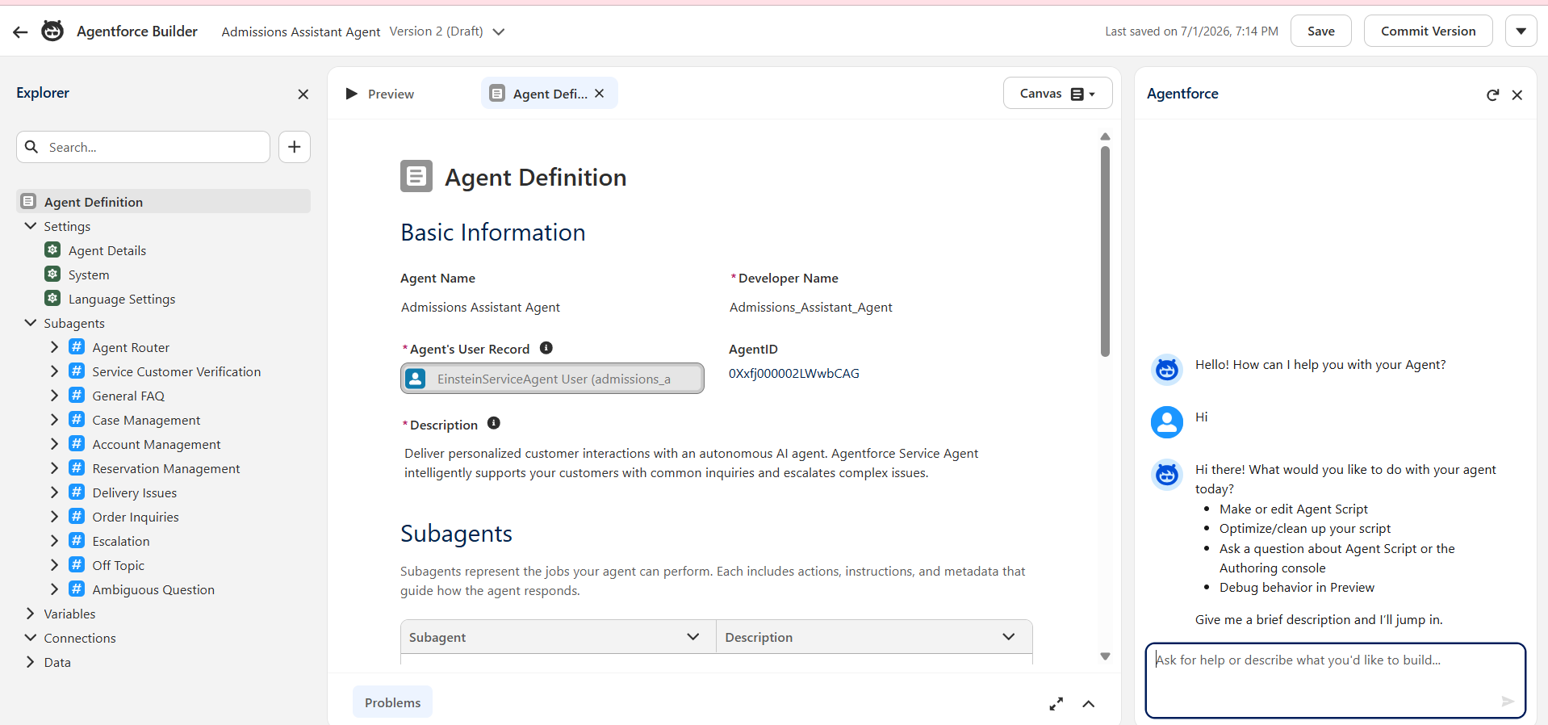
Features Implemented
During the implementation of Agentforce AI, the following intelligent features were developed:
- Automatic generation of student application summaries.
- AI-based enrollment risk analysis.
- Intelligent approval recommendations for admission managers.
- Context-aware responses using Salesforce data.
- Support for admission counselors in reviewing student applications.
- Integration with Salesforce Flows and Approval Processes.

Outcome
The Agentforce AI implementation was successfully completed and integrated with the Student Admissions & Support Management System. The AI agent assists admission counselors by automatically generating student application summaries, analyzing enrollment risks, and providing approval recommendations based on available data. The implementation reduced manual effort, improved the speed and accuracy of admission decisions, enhanced productivity, and demonstrated the practical use of Salesforce's generative AI capabilities within an educational admission management system

Milestone 11 – Lightning App
Objective
The objective of this milestone is to create a custom Lightning App for the AI-Enabled Student Admissions & Support Management System. The Lightning App provides a centralized workspace for admission counselors and managers to access student records, course details, enrollment information, reports, dashboards, and AI-powered features from a single interface.
Introduction
A Lightning App in Salesforce is a collection of tabs, objects, utilities, and navigation items designed to support specific business processes. It provides users with an organized and user-friendly interface, allowing them to efficiently access all the resources required for their daily tasks.
In this project, a custom Lightning App named Student Admission was created to manage the complete student admission lifecycle. The app integrates standard objects, custom objects, reports, dashboards, and AI features into a single workspace, improving productivity and simplifying navigation.
Lightning App Configuration
Property | Value
App Name | Student Admission
App Type | Lightning App
Navigation Style | Standard Navigation
Assigned Profiles | System Administrator, Admission Manager, Admission Counselor
Utility Bar | Enabled
Status | Active

Navigation Items
The following navigation items were added to the Lightning App:
- Home
- Contact (Students)
- Opportunity (Admissions)
- Course
- Student Enrollment
- Reports
- Dashboards
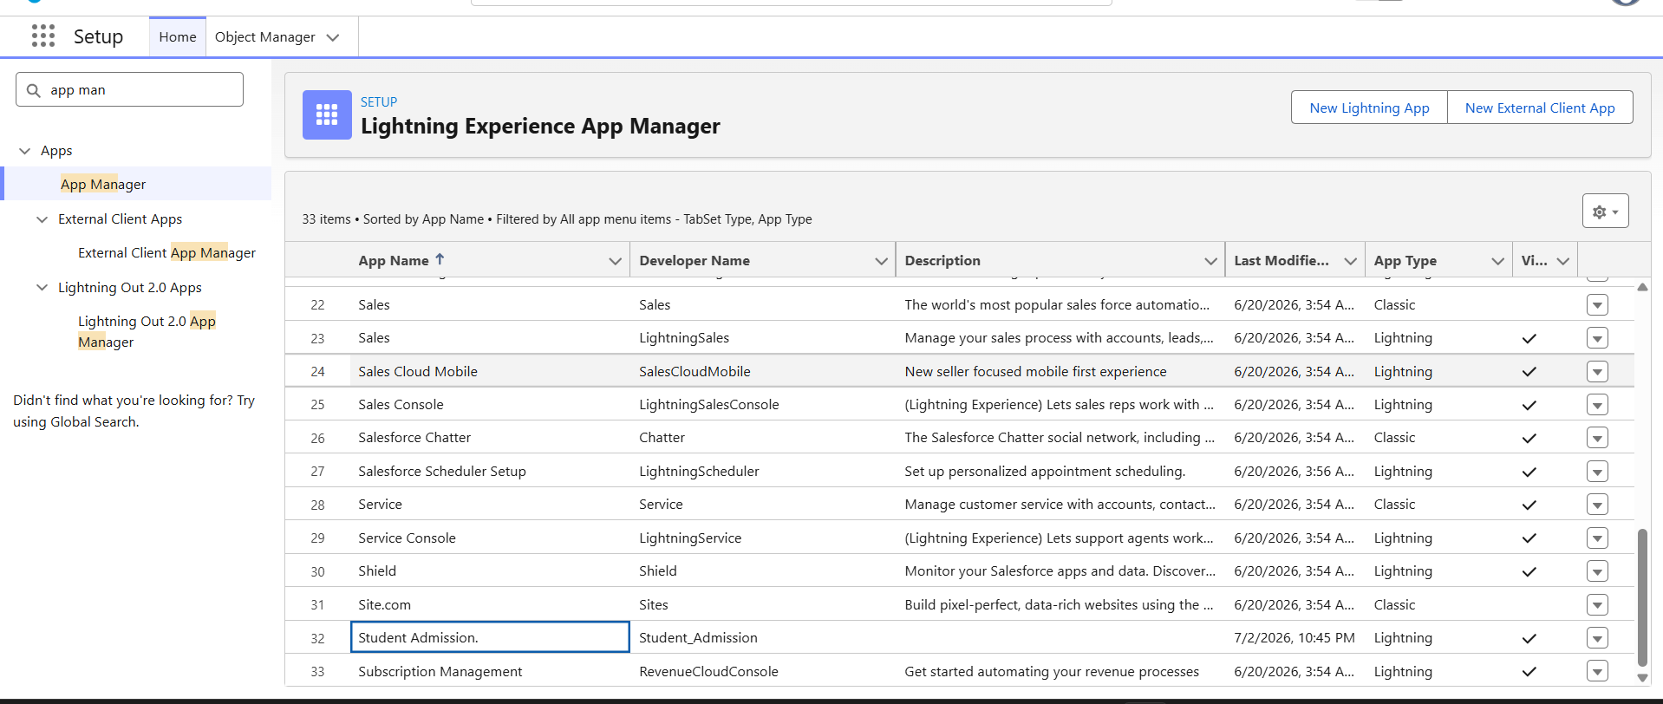

Implementation Steps
The following activities were completed during this milestone:
- Opened Salesforce Setup.
- Navigated to App Manager.
- Clicked New Lightning App.
- Entered the App Name as Student Admission.
- Configured the app branding and navigation style.
- Added the required navigation items, including Contact, Opportunity, Course, Student Enrollment, Reports, and Dashboards.
- Assigned the application to the required user profiles.
- Configured the Utility Bar.
- Saved the Lightning App.
- Activated the application.
- Verified that all required objects and navigation tabs were accessible from the application.

Outcome
The Student Admission Lightning App was successfully created and configured in Salesforce. The application provides a centralized and organized interface for managing student admissions, course information, and enrollment records. It enables admission counselors and managers to efficiently access standard and custom objects, reports, dashboards, and automation features from a single workspace. The Lightning App enhances usability, improves navigation, and supports the overall functionality of the AI-Enabled Student Admissions & Support Management System.

Milestone 12 – Editing of Page Layouts
Objective
The objective of this milestone is to customize the page layouts of standard and custom objects in the AI-Enabled Student Admissions & Support Management System. Page layout customization ensures that users can easily view, create, and update records by displaying only the relevant fields and related information required for the admission process.
Introduction
A Page Layout in Salesforce controls how fields, related lists, buttons, and other record details are displayed to users. By customizing page layouts, organizations can improve user experience, simplify data entry, and ensure that important information is easily accessible.
In this project, the page layouts of the Contact, Opportunity, Course, and Student Enrollment objects were customized to organize fields logically and support the admission workflow.
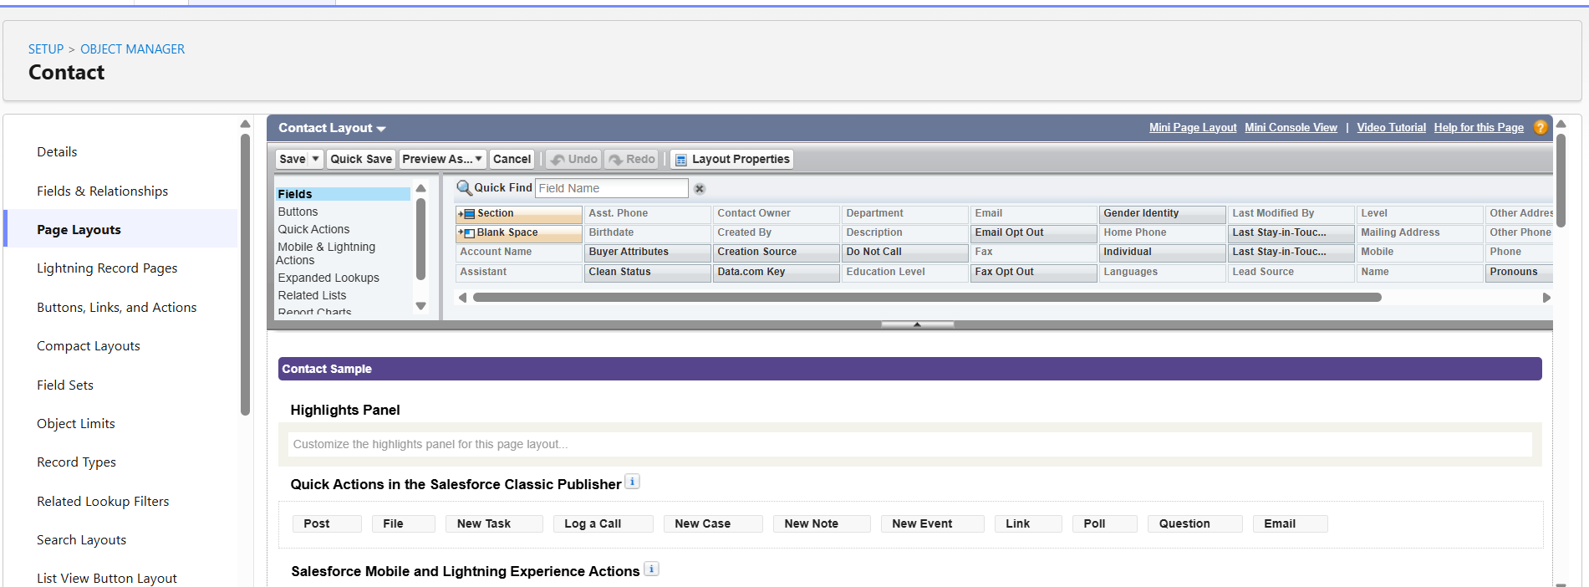
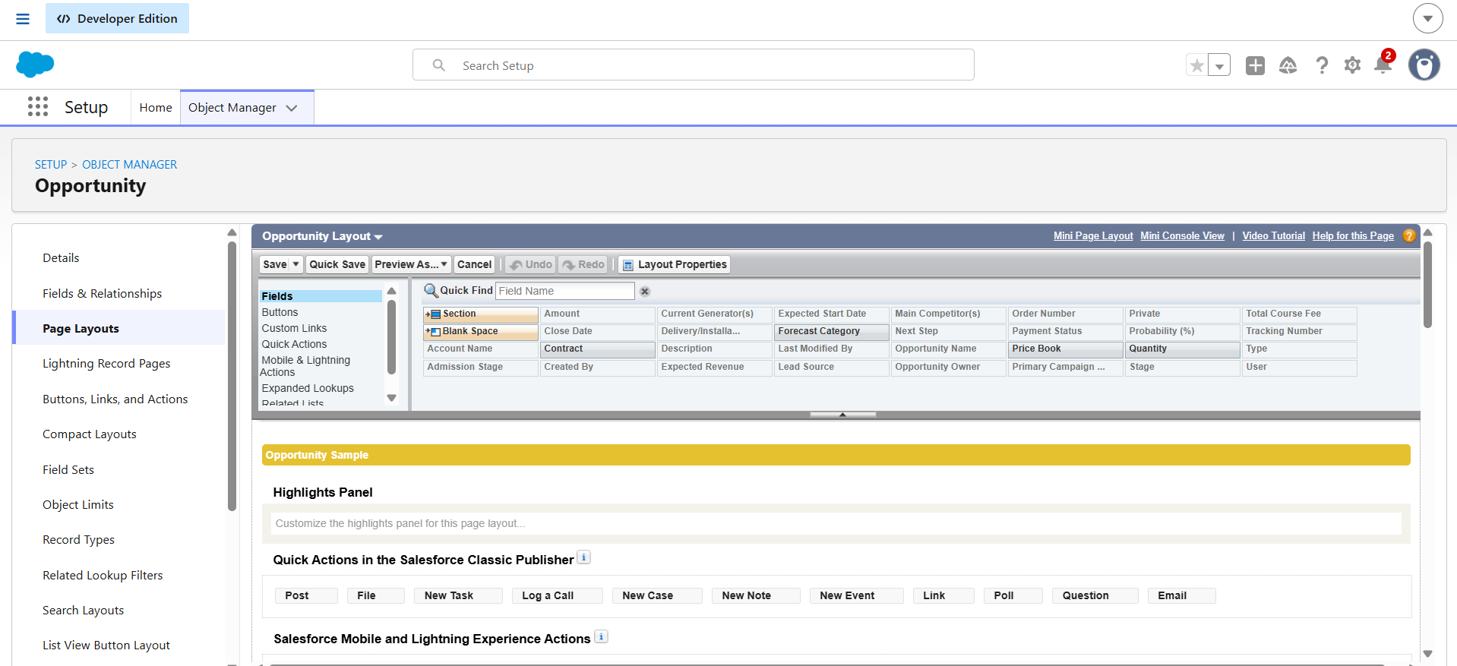

Objects Customized
The following objects were customized during this milestone:
Object | Customization
Contact | Added custom student information fields to the page layout.
Opportunity | Added admission-related fields such as Admission Stage, Payment Status, Expected Start Date, Counselor Assigned, and Total Course Fee.
Course | Added course-specific fields including Course Code, Category, Fee, Duration, Status, and Capacity.
Student Enrollment | Added enrollment details such as Student, Course, Enrollment Date, Discount Percentage, Approval Status, Payment Status, and Final Payable Amount.

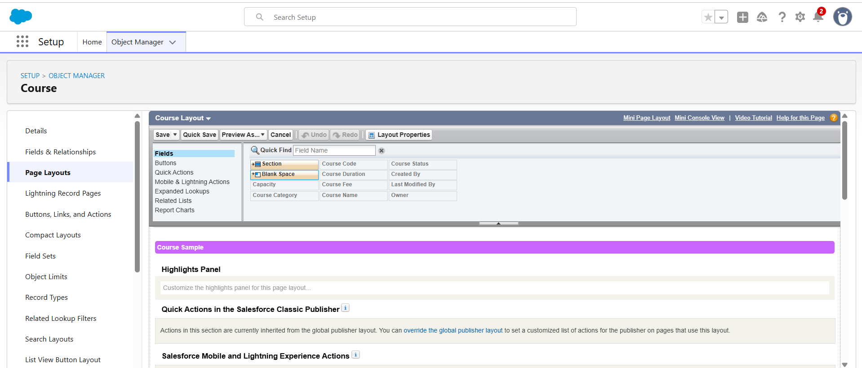

Implementation Steps
The following activities were completed during this milestone:
- Opened Salesforce Setup.
- Navigated to Object Manager.
- Selected the required object.
- Opened the Page Layouts section.
- Selected the default page layout for editing.
- Dragged and dropped the required custom fields onto the page layout.
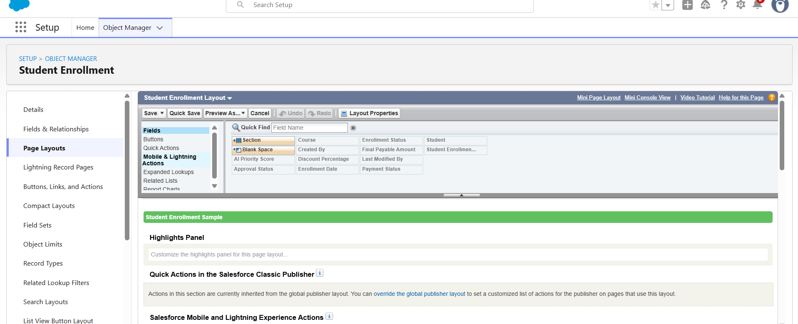
- Arranged the fields into appropriate sections for better readability.
- Added the required related lists to the page layout.
- Saved the page layout.
- Repeated the same process for all standard and custom objects.
- Verified that the customized layouts displayed correctly in the Lightning App.

Outcome
The page layouts were successfully customized for the Contact, Opportunity, Course, and Student Enrollment objects. The customized layouts provide a structured and user-friendly interface by displaying relevant fields in an organized manner. This improves data entry efficiency, simplifies record management, enhances user productivity, and supports the overall admission workflow within the AI-Enabled Student Admissions & Support Management System.

Milestone 13 - Dynamic Forms
Objective
The objective of this milestone is to implement Dynamic Forms to create a more flexible and user-friendly record page by displaying fields and sections dynamically based on business requirements. Dynamic Forms improve usability by showing only the information relevant to the user.
Introduction
Dynamic Forms is a Salesforce Lightning feature that enables administrators to place individual fields and sections directly on Lightning Record Pages without relying solely on traditional page layouts. Visibility rules can be applied to fields and sections so that information is displayed only when specific conditions are met.
In this project, Dynamic Forms were implemented to improve the Student Enrollment record page by organizing information into logical sections and displaying relevant fields based on the record data.

Dynamic Form Configuration
Component | Configuration
Record Page | Student Enrollment Record Page
Feature Used | Dynamic Forms
Sections Created | Student Information, Course Details, Enrollment Information, Approval Details, Payment Information
Visibility Rules | Configured based on field values where applicable
Status | Active

Implementation Steps
The following activities were completed during this milestone:
- Opened Salesforce Setup.
- Navigated to Object Manager.
- Selected the Student Enrollment object.
- Opened the Lightning Record Page.
- Clicked Edit Page to launch Lightning App Builder.
- Upgraded the page layout to Dynamic Forms.
- Added Field Sections to organize related information.
- Dragged individual fields into their respective sections.
- Configured field visibility rules where required.
- Saved the Lightning Record Page.
- Activated the page for the required application and user profiles.
- Verified that the Dynamic Form displayed fields correctly based on the configured layout.
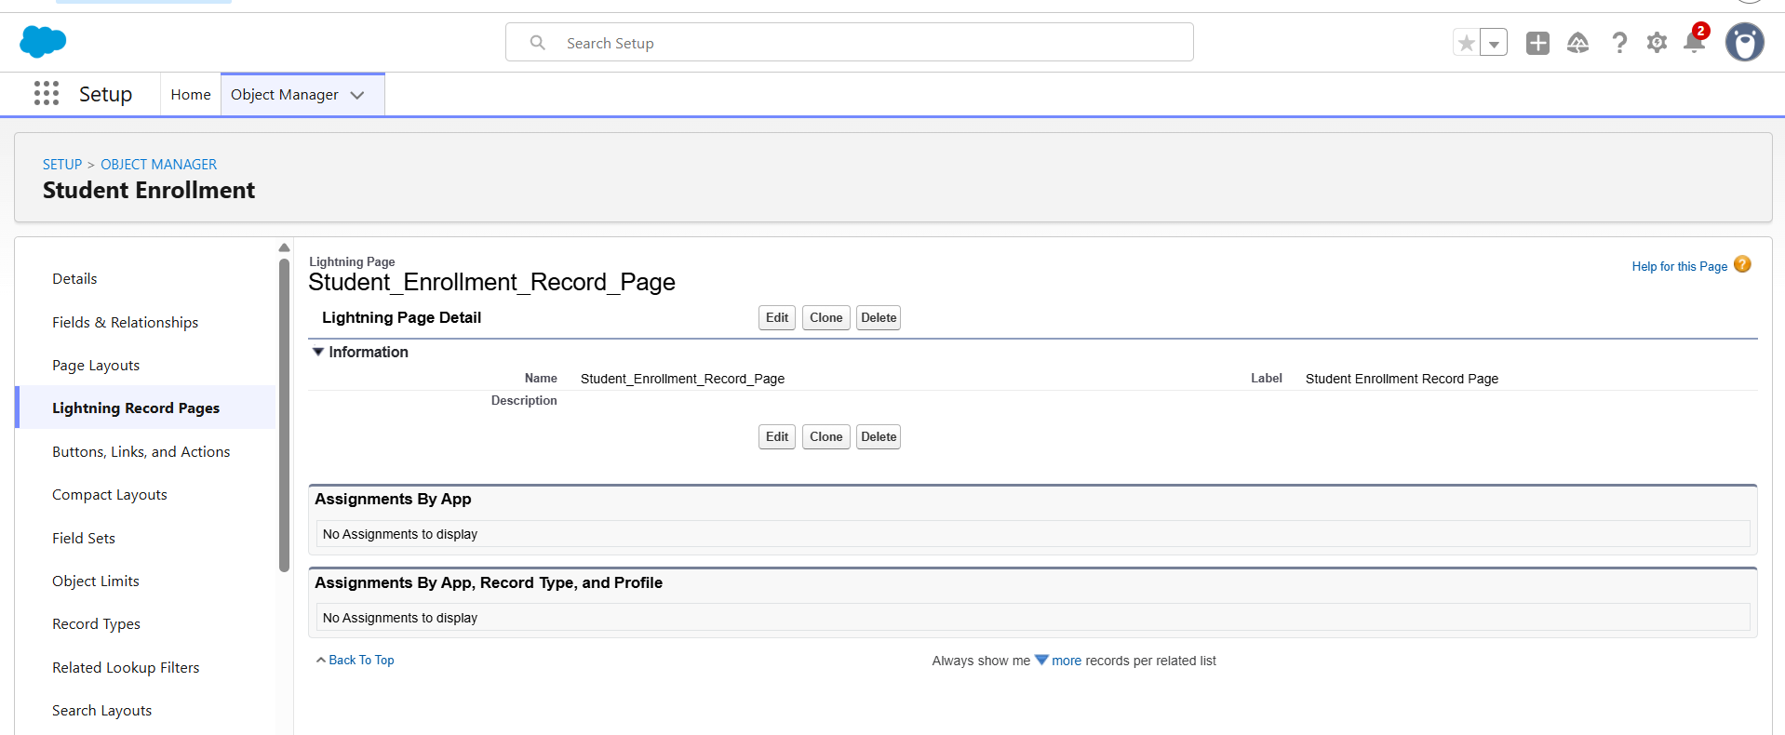
Outcome
Dynamic Forms were successfully implemented for the Student Enrollment object. The record page was organized into logical sections, making it easier for users to access and update information. The implementation improved the user experience, reduced page clutter, simplified navigation, and enhanced the efficiency of the student admission process by presenting only relevant information on the Lightning Record Page.

Milestone 14 – Users
Objective
The objective of this milestone is to create and manage Salesforce users for the AI-Enabled Student Admissions & Support Management System. User management ensures that authorized personnel can securely access the application based on their assigned roles and responsibilities.
Introduction
Users in Salesforce represent individuals who access the system to perform specific business operations. Each user is assigned a profile, role, and login credentials that determine the level of access and permissions available within the organization.
In this project, users were created for the Admission Manager and Admission Counselor to support the student admission process. Appropriate profiles and roles were assigned to ensure secure access to records, reports, dashboards, and AI-powered features.

Users Created
User Name | Role | Profile | Purpose
Admission Manager | Admission Manager | System Administrator / Custom Profile | Reviews and approves student enrollments, manages admission activities, and monitors reports.
Admission Counselor | Admission Counselor | Standard User / Custom Profile | Manages student applications, course enrollments, and communicates with students throughout the admission process.

User Configuration
Property | Value
User License | Salesforce
Profile | System Administrator / Standard User
Role | Admission Manager / Admission Counselor
Username | Unique Email Address
Alias | Auto Generated
Email | User Email Address
Active | Enabled

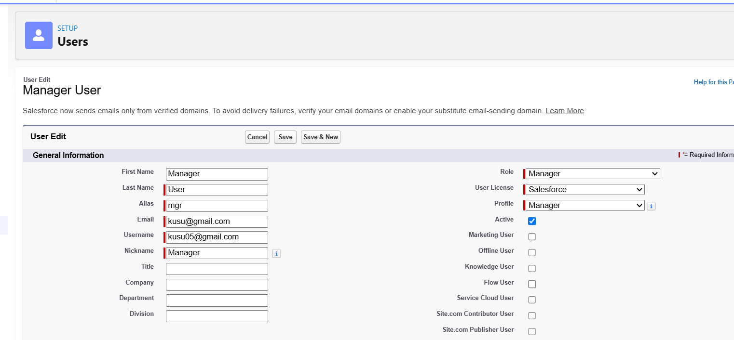

Implementation Steps
The following activities were completed during this milestone:
- Opened Salesforce Setup.
- Navigated to Users.
- Clicked New User.
- Entered the user's First Name, Last Name, and Email Address.
- Specified a unique Username.
- Selected the appropriate User License.
- Assigned the required Profile.
- Assigned the corresponding Role.
- Enabled the Active option.
- Saved the user record.
- Repeated the process for all required users.
- Verified that the users could successfully access the Student Admission Lightning App according to their assigned roles and permissions.
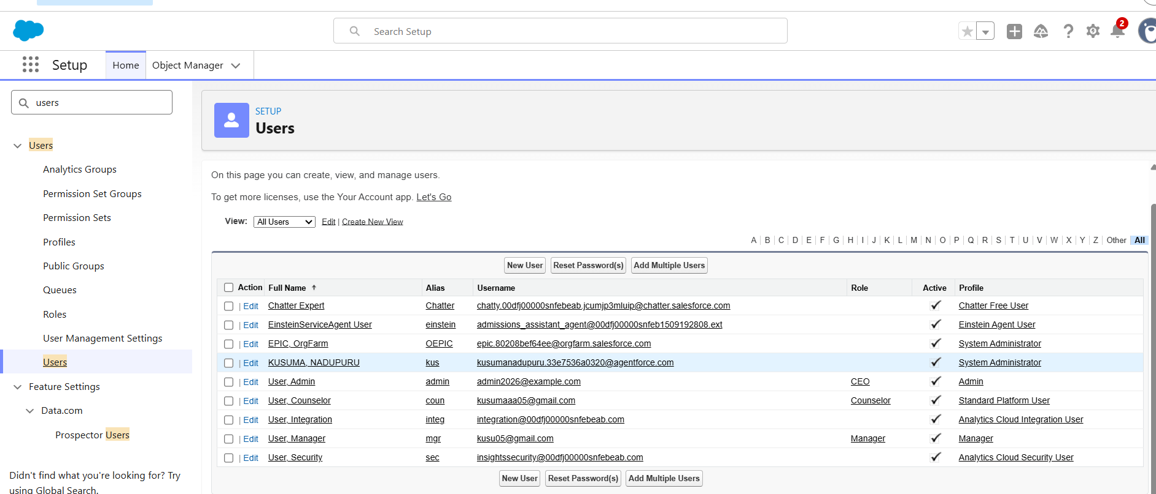
Outcome
The required Salesforce users were successfully created and configured for the AI-Enabled Student Admissions & Support Management System. Appropriate profiles and roles were assigned to ensure secure and role-based access to the application. The implemented user management supports efficient collaboration between Admission Managers and Admission Counselors while maintaining data security and controlled access to system resources.

Milestone 15 - Duplicate and Matching Rules
Objective
The objective of this milestone is to implement Duplicate Rules and Matching Rules in Salesforce to prevent the creation of duplicate student records and maintain data quality within the AI-Enabled Student Admissions & Support Management System.
Introduction
Duplicate records can lead to inconsistent data, inaccurate reports, and inefficient business processes. Salesforce provides Matching Rules to identify potential duplicate records based on selected fields and Duplicate Rules to define the actions that should be taken when duplicates are detected.
In this project, Matching Rules and Duplicate Rules were configured on the Contact object to ensure that each student is registered only once in the system. This helps maintain accurate student information and improves the overall reliability of the admission process.
Duplicate Rule Configuration
Property | Value
Object | Contact
Matching Rule | Contact Matching Rule
Action on Create | Alert User
Action on Edit | Alert User
Allow Save | Disabled
Status | Active

Matching Rule Configuration
Property | Value
Object | Contact
Matching Criteria | Student Name, Email, Phone Number
Matching Method | Exact Match
Status | Active

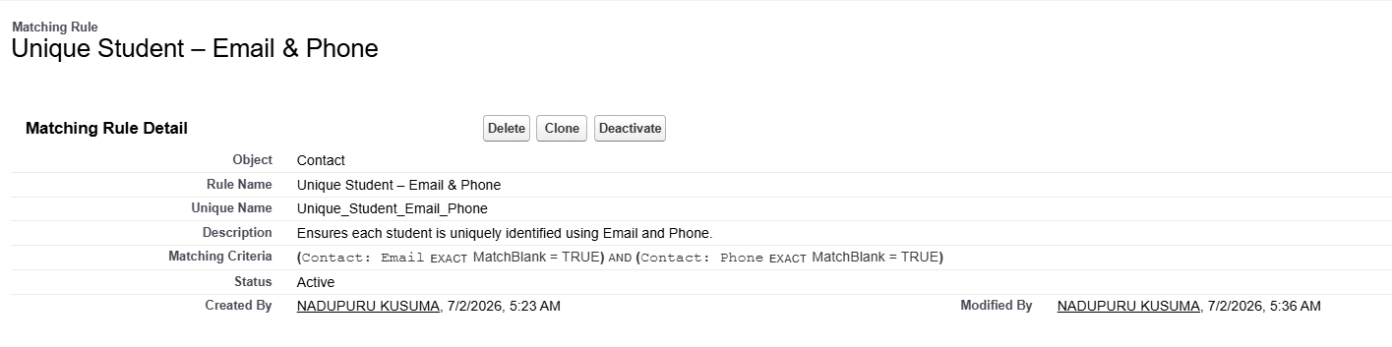
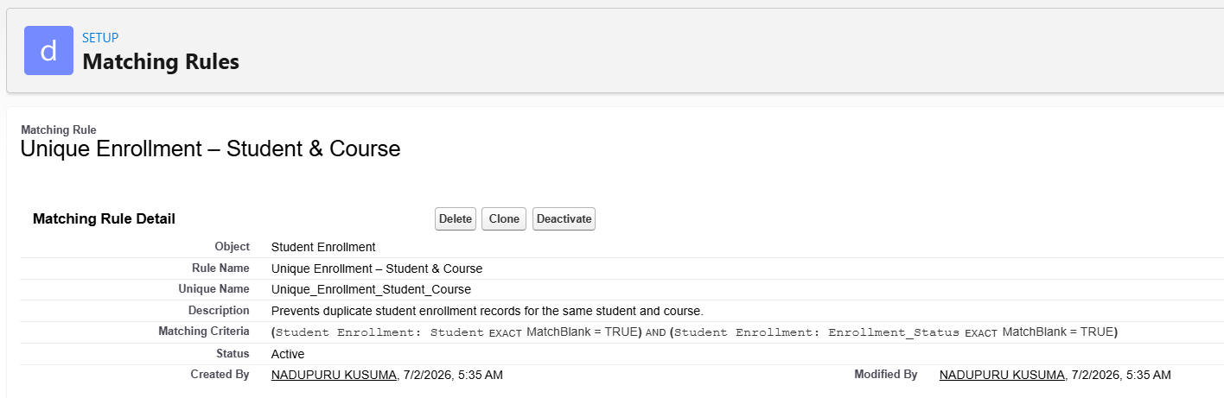
Implementation Steps
The following activities were completed during this milestone:
- Opened Salesforce Setup.
- Navigated to Matching Rules.
- Created a new Matching Rule for the Contact object.
- Added the required matching criteria such as Student Name, Email Address, and Phone Number.
- Saved and activated the Matching Rule.
- Navigated to Duplicate Rules.
- Created a new Duplicate Rule for the Contact object.
- Selected the previously created Matching Rule.
- Configured the rule to display an alert when duplicate records are detected.
- Disabled duplicate record creation.
- Saved and activated the Duplicate Rule.
- Tested the rule by attempting to create duplicate student records.
- Verified that Salesforce successfully detected and prevented duplicate entries.
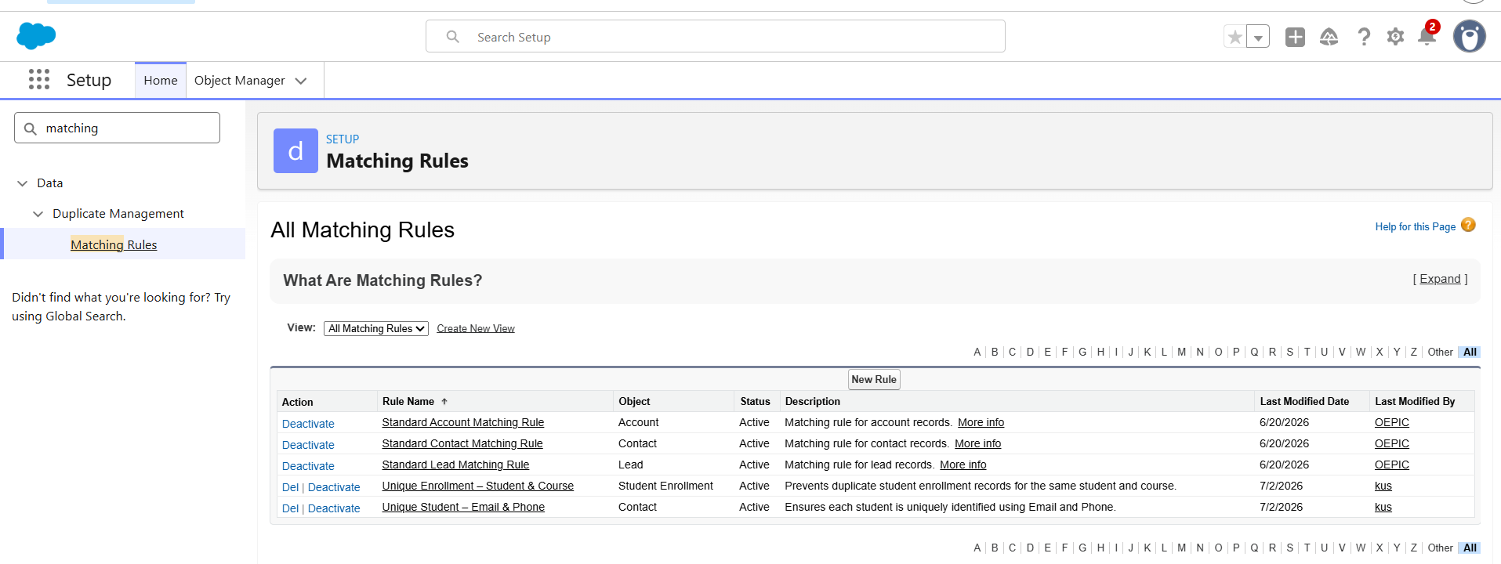
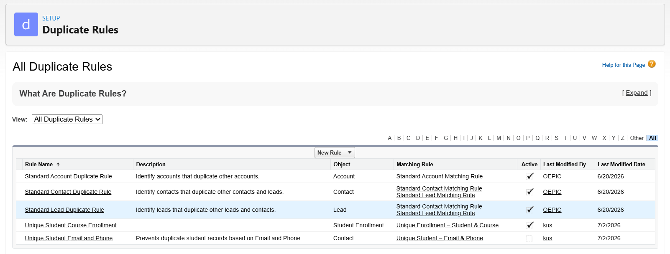
Outcome
Duplicate Rules and Matching Rules were successfully implemented on the Contact object. The system now identifies duplicate student records before they are created, preventing redundant data and improving data quality. This implementation ensures accurate student information, enhances reporting reliability, and supports efficient management of the student admission process.

Milestone 16: Profiles
Objective
The objective of this milestone is to create and configure Profiles in Salesforce to control user permissions and ensure secure access to the AI-Enabled Student Admissions & Support Management System. Profiles define the level of access that users have to objects, fields, applications, and system features based on their job responsibilities.
Introduction
A Profile in Salesforce is a collection of permissions and settings assigned to users. It determines what users can view, create, edit, or delete within the organization. Profiles also control access to applications, tabs, Apex classes, Visualforce pages, and object-level permissions.
In this project, separate profiles were configured for Admission Managers and Admission Counselors to provide role-based access while maintaining data security. The profiles ensure that users can perform only the tasks relevant to their responsibilities.
Profiles Configured
Profile Name | Purpose
System Administrator | Full administrative access to configure and manage the Salesforce organization.
Admission Manager | Manages student admissions, reviews enrollment requests, approves applications, and accesses reports and dashboards.
Admission Counselor | Manages student records, enrollments, and course information with limited administrative permissions.

Profile Permissions
Permission | Admission Manager | Admission Counselor
Contact | Create, Read, Edit | Create, Read, Edit
Opportunity | Create, Read, Edit | Create, Read, Edit
Course | Create, Read, Edit | Read
Student Enrollment | Create, Read, Edit | Create, Read, Edit
Reports | Enabled | Enabled
Dashboards | Enabled | Enabled
Approval Process | Approve Records | View Only
Agentforce AI | Enabled | Enabled

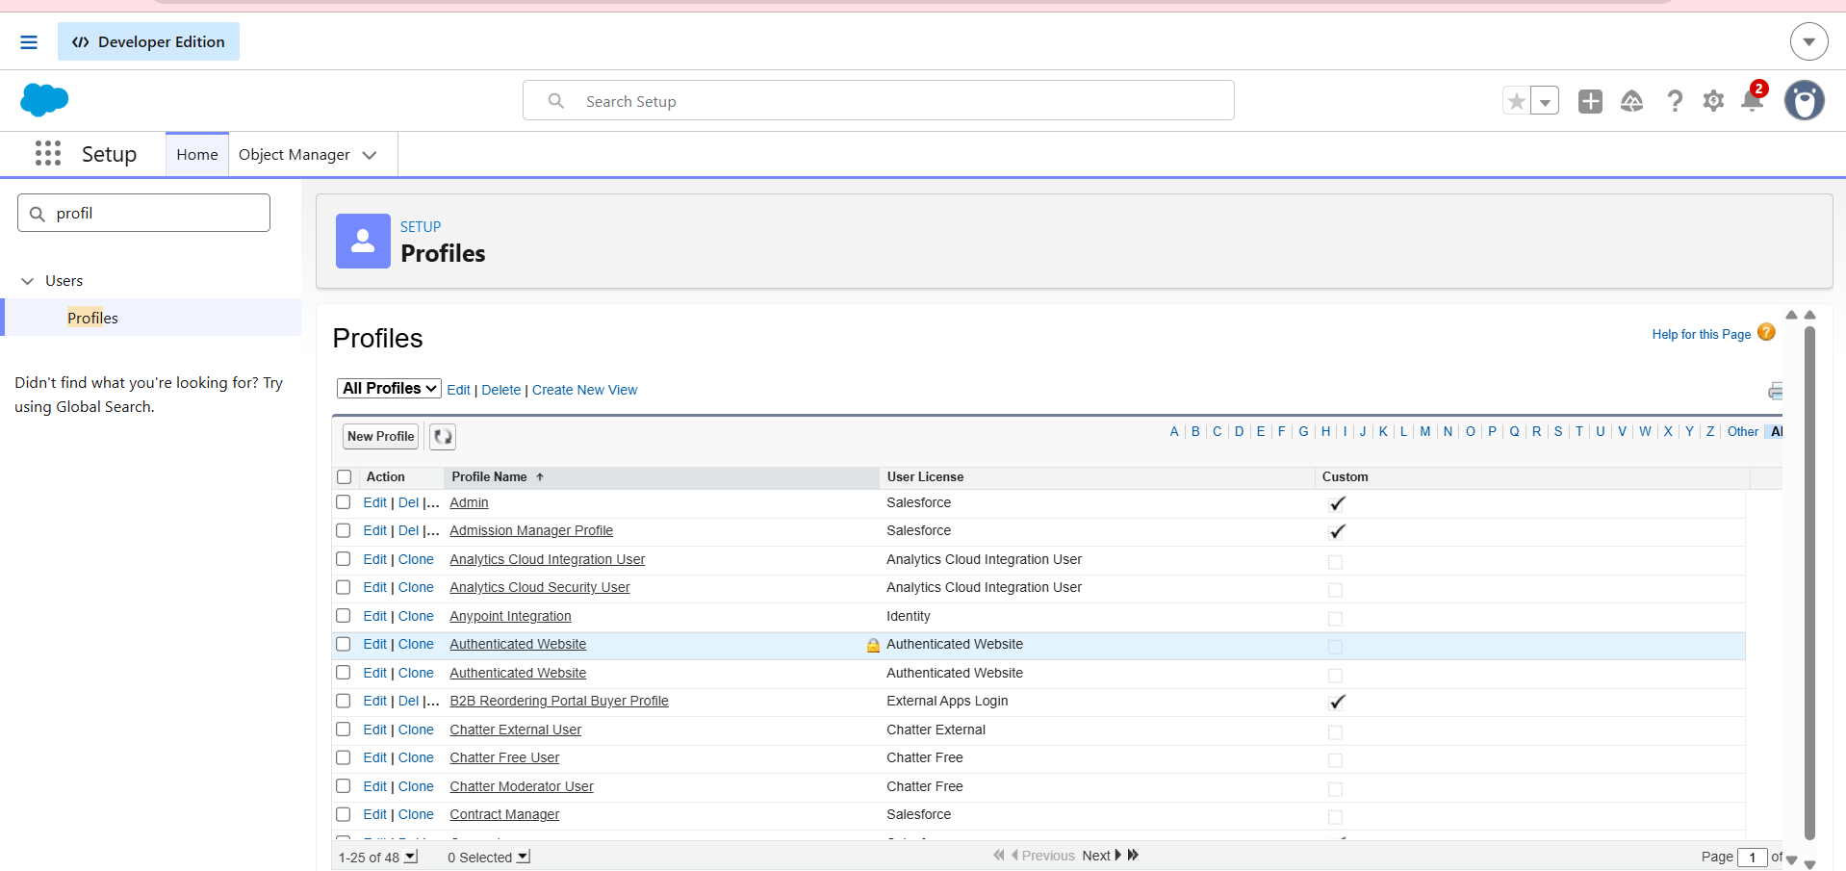

Implementation Steps
The following activities were completed during this milestone:
- Opened Salesforce Setup.
- Navigated to Profiles.
- Reviewed the available standard profiles.
- Created or configured profiles according to project requirements.
- Assigned object-level permissions for Contact, Opportunity, Course, and Student Enrollment.
- Configured field-level security where required.
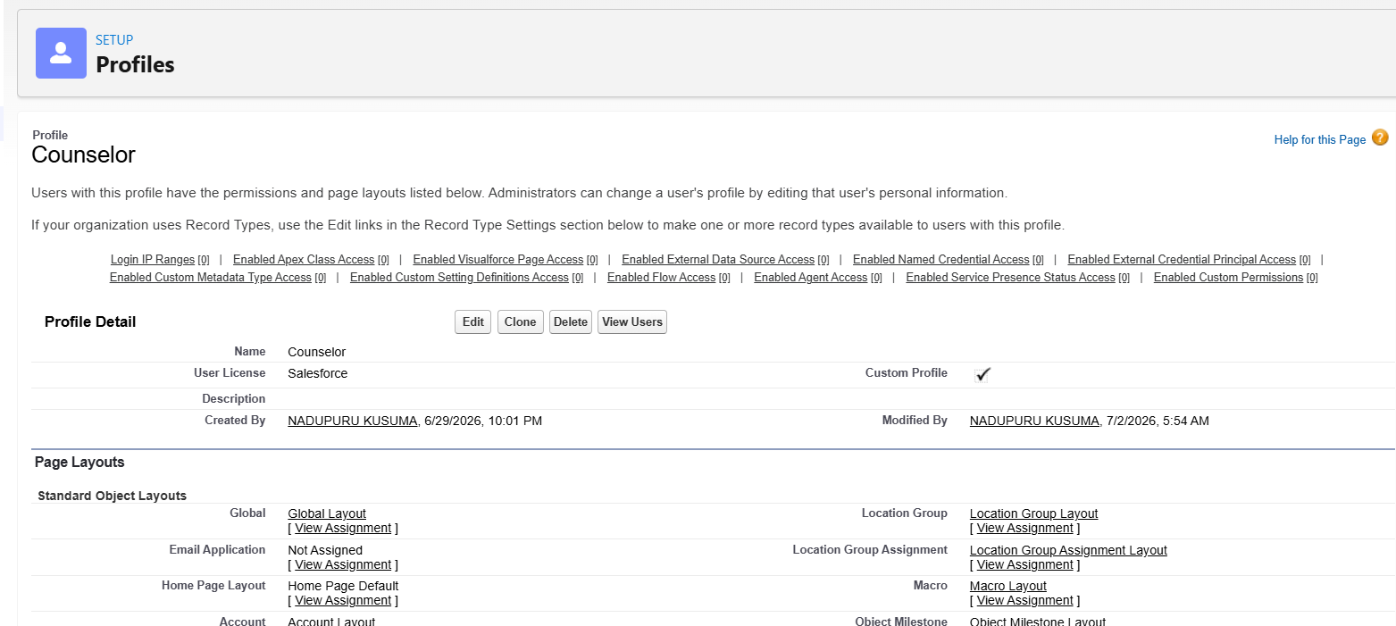
- Enabled access to the Student Admission Lightning App.
- Assigned tab visibility for standard and custom objects.
- Granted permissions for Reports and Dashboards.
- Assigned the appropriate profiles to the Admission Manager and Admission Counselor users.
- Verified user access by logging in with the assigned profiles.

Outcome
Profiles were successfully configured to provide secure and role-based access to the AI-Enabled Student Admissions & Support Management System. The implemented profiles ensure that users can access only the resources required for their responsibilities, improving system security, protecting sensitive data, and supporting efficient management of the student admission process.

Milestone 17: Roles & Role Hierarchy
Objective
The objective of this milestone is to create and configure Roles and establish a Role Hierarchy in Salesforce for the AI-Enabled Student Admissions & Support Management System. The role hierarchy ensures that users have appropriate record visibility based on their organizational responsibilities while supporting efficient collaboration between admission counselors and managers.
Introduction
A Role Hierarchy in Salesforce controls record-level access by allowing users higher in the hierarchy to view, edit, and report on records owned by users below them. It reflects the organizational structure and facilitates secure data sharing without granting unnecessary permissions.
In this project, a role hierarchy was created to represent the admission department. The Admission Manager was assigned as the parent role, while the Admission Counselor was created as a child role. This hierarchy enables managers to monitor and manage records owned by counselors while maintaining an organized reporting structure.
Roles Created
Role Name | Reports To | Purpose
Admission Manager | CEO (or Top-Level Role) | Oversees the complete admission process, approves student enrollments, and manages admission activities.
Admission Counselor | Admission Manager | Handles student applications, manages enrollments, and reports to the Admission Manager.

Role Hierarchy Structure
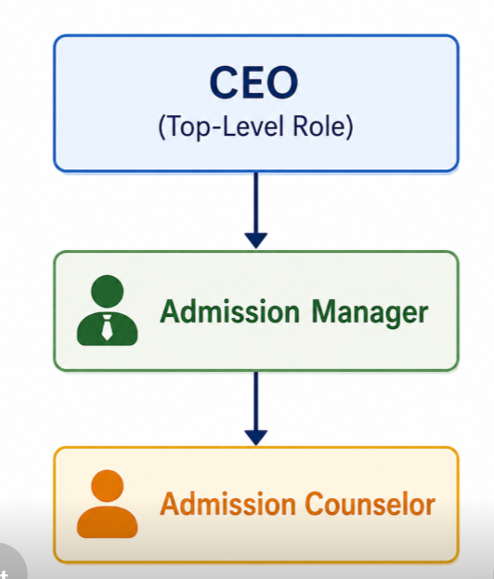
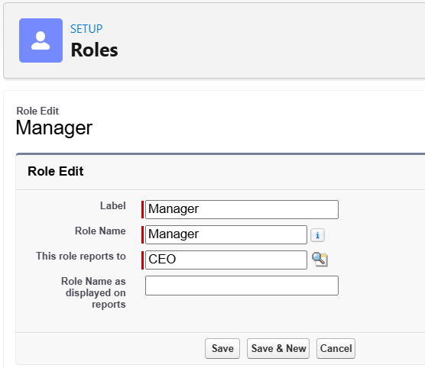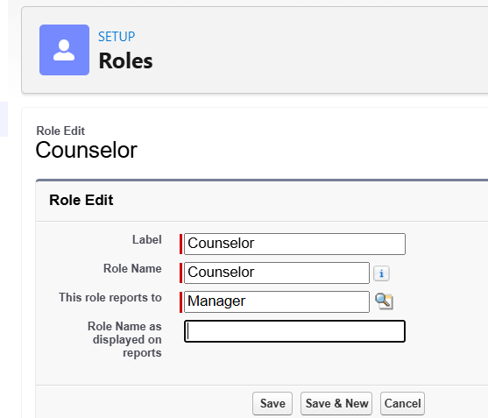

Implementation Steps
The following activities were completed during this milestone:
- Opened Salesforce Setup.
- Navigated to Roles.
- Opened the Set Up Roles page.
- Created the Admission Manager role under the top-level organizational role.
- Entered the Role Label and verified the automatically generated Role Name.
- Saved the Admission Manager role.
- Created the Admission Counselor role under the Admission Manager role.
- Entered the Role Label and verified the Role Name.
- Saved the Admission Counselor role.
- Assigned the appropriate roles to the corresponding Salesforce users.
- Verified that the role hierarchy displayed correctly.
- Confirmed that the Admission Manager could access records owned by the Admission Counselor.
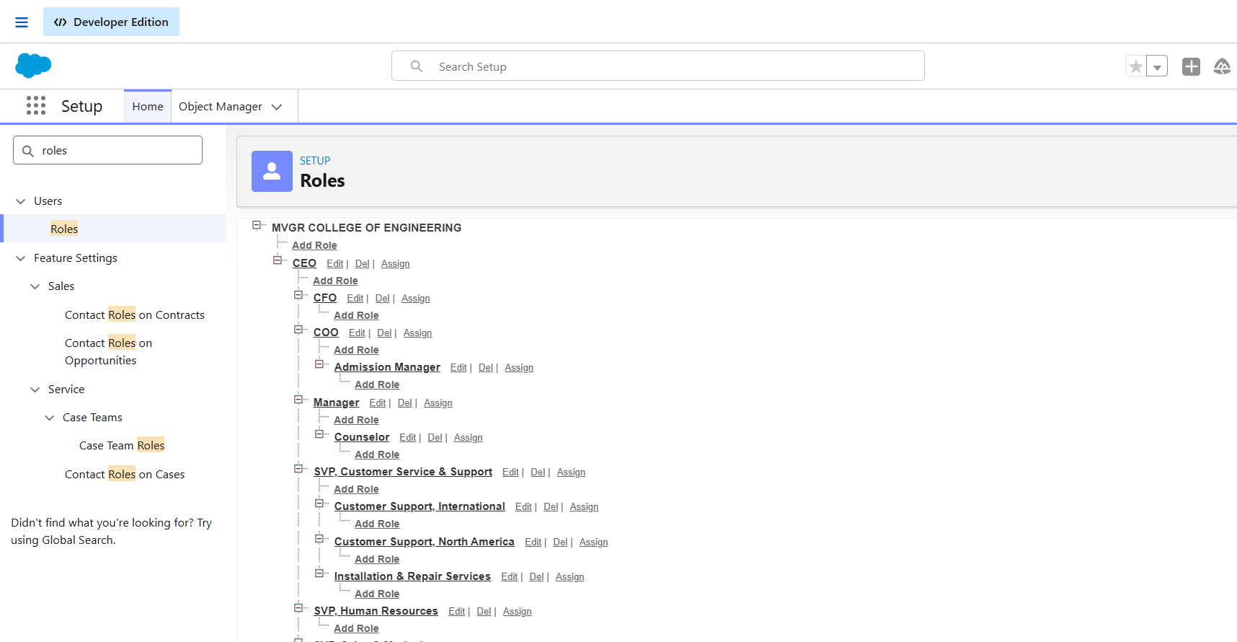
Outcome
The Roles and Role Hierarchy were successfully configured in Salesforce for the AI-Enabled Student Admissions & Support Management System. The implemented hierarchy accurately reflects the organizational structure, enabling Admission Managers to supervise and access records managed by Admission Counselors. This configuration improves collaboration, supports secure record sharing, and enhances the efficiency of the student admission process while maintaining proper access control.

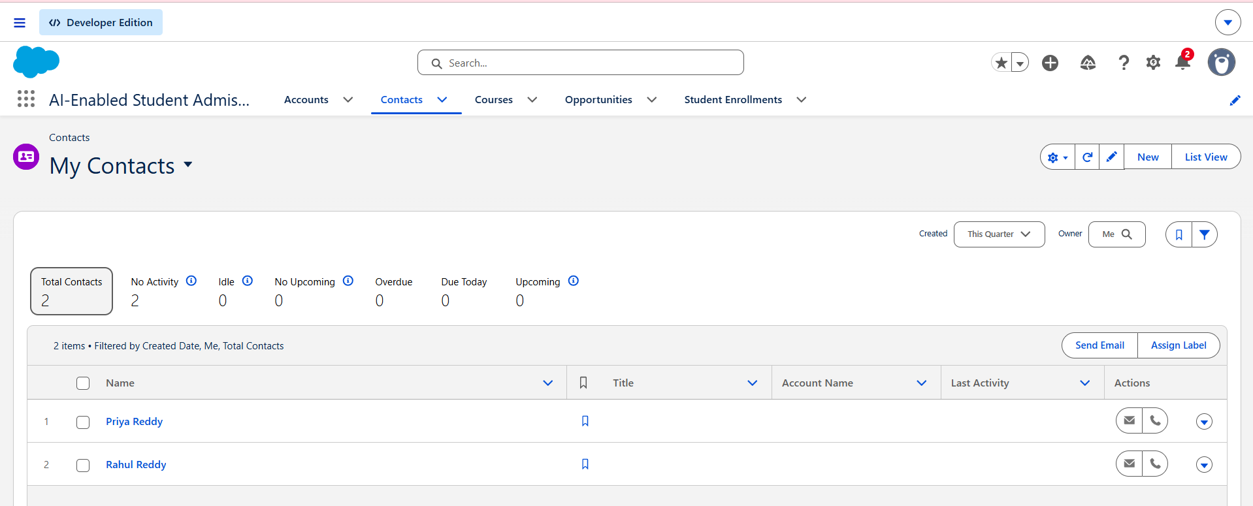
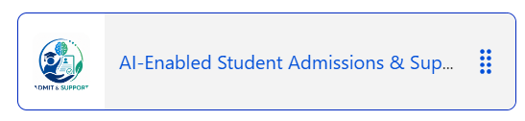

7. FUNCTIONAL & PERFORMANCE TESTING
The developed AI-Enabled Student Admissions & Support Management System was tested to verify the functionality of all implemented features. Testing ensured that the system performed according to the project requirements and business logic.
The following functionalities were successfully verified:
- Creation and management of Contact, Opportunity, Course, and Student Enrollment records.
- Validation Rules to ensure accurate data entry.
- Approval Process for high-discount student enrollments.
- Email Templates and Email Alerts for automated notifications.
- Record-Triggered Flows for automating admission-related processes.
- Lightning App navigation and customized Page Layouts.
- Dynamic Forms for improved user experience.
- User, Profile, and Role Hierarchy configuration.
- Duplicate Rules and Matching Rules to prevent duplicate student records.
- Agentforce AI configuration and integration with the Student Enrollment process.
The system demonstrated reliable performance by automating repetitive tasks, reducing manual effort, maintaining data consistency, and providing a centralized platform for managing student admissions.

8. ADVANTAGES & DISADVANTAGES
Advantages
- Centralized management of student admissions and enrollment records.
- Automation of repetitive tasks using Salesforce Flows.
- Improved data accuracy through Validation Rules.
- Prevention of duplicate student records using Duplicate and Matching Rules.
- Automated approval workflow for high-discount enrollments.
- Faster communication through Email Templates and Email Alerts.
- Secure access control using Profiles and Role Hierarchy.
- User-friendly interface through Lightning App and Dynamic Forms.
- AI-powered assistance using Agentforce AI to support admission decision-making.
- Scalable solution capable of supporting future organizational requirements.

Disadvantages
- Initial Salesforce configuration requires adequate administrative knowledge.
- Advanced AI features require proper Agentforce configuration and licensing.
- Customizations may require periodic maintenance as business requirements evolve.
- Dependence on internet connectivity and Salesforce platform availability.
- Some advanced features may require additional Salesforce editions or licenses.

9. CONCLUSION
The AI-Enabled Student Admissions & Support Management System was successfully designed and implemented using the Salesforce Platform. The system effectively manages student information, course details, enrollment records, approvals, and automated communications through Salesforce's declarative features.
The project demonstrates the practical application of Salesforce technologies, including Lightning Apps, Custom Objects, Validation Rules, Approval Processes, Flows, Dynamic Forms, Email Automation, Profiles, Roles, and Agentforce AI. These features work together to improve operational efficiency, minimize manual intervention, and ensure secure and accurate management of the admission process.
Overall, the project provides a modern, scalable, and intelligent solution for educational institutions to streamline their student admission workflow while showcasing the capabilities of Salesforce as a low-code CRM platform.

10. FUTURE SCOPE
The project can be further enhanced by incorporating additional Salesforce and AI capabilities, including:
- Integration with external Student Information Systems (SIS).
- Online student application portal using Experience Cloud.
- AI-powered chatbot for admission-related queries.
- Integration with payment gateways for online fee collection.
- Automated document verification using AI services.
- Mobile application integration for students and counselors.
- Advanced dashboards using CRM Analytics (Tableau CRM).
- Multi-campus admission management.
- Integration with Learning Management Systems (LMS).
These enhancements would further improve automation, user experience, and decision-making capabilities.
11. APPENDIX
Source Code
Since the project was developed using Salesforce's declarative (low-code) platform, no traditional programming source code was required. The application was implemented using Salesforce configuration features such as:
- Lightning App
- Custom Objects
- Custom Fields
- Validation Rules
- Approval Processes
- Record-Triggered Flows
- Email Templates
- Email Alerts
- Dynamic Forms
- Profiles
- Roles & Role Hierarchy
- Duplicate & Matching Rules
- Agentforce AI Configuration
Dataset
The project utilizes sample educational data, including:
- Student Records
- Course Information
- Student Enrollment Records
- Admission Details
- Payment Information
- Approval Status Records
Tools Used
- Salesforce Developer Org
- Salesforce Lightning Experience
- Salesforce Flow Builder
- Salesforce Object Manager
- Approval Process
- Agentforce AI
- Prompt Builder
- Email Templates & Email Alerts
- Reports & Dashboards
- Google Chrome
- Microsoft Word (Documentation)

ACKNOWLEDGEMENT
I sincerely express my gratitude to SmartBridge, Salesforce, and my mentors for providing the opportunity to work on this internship project. The guidance, learning resources, and hands-on experience gained throughout the internship have significantly enhanced my understanding of Salesforce administration, declarative development, automation, and AI-powered CRM solutions.
This project has strengthened my practical knowledge of Salesforce and provided valuable industry exposure that will support my future professional growth.

THANK YOU
AI-Enabled Student Admissions & Support Management System
Salesforce Internship Project Report

